31-01-2015

Deliverable 323:
Possibilities for Grouper in a cross/inter organizational use: PoC Documentation
Milestone Deliverable 323
Contractual Date: | 31-12-2014
Actual Date: | 31-01-2015
Grant Agreement No.:
Work Package/Activity: | JRA3
Task Item: | T1
Nature of Deliverable:
Dissemination Level:
Lead Partner: | Consortium GARR
Document Code: | JRA3-T1-323
Authors | A. Biancini (GARR)
Contributors | M.L. Mantovani (GARR), M. Malavolti (GARR), M. Kremers (SURFnet)
© GN3plus project.
The research leading to these results has received funding from the European Community’s Seventh Framework Programme (FP7 2007–2013) under Grant Agreement No. 605243 (GN3plus).

Abstract
Possibilities for Grouper in a cross/inter organizational use is part of the JRA3 T1 Task aimed at implementing support for groups in Identity Federations. The task will investigate attribute management models where attributes are also provided by third parties sources, assisting NRENs, individual institutions and Large Projects to gain or provide access to federated services. The Grouper subtask will explore the opportunities to use Grouper as a tool, at a federation level, to centralize authorization information about users.

This deliverable, in particular will describe a step by step guide about how to install Grouper and the MediaWiki and Moodle application to replicate the PoC realized in the activities of this task.

Table of Contents
1 Introduction 1
2 Installation of Grouper 2
2.1 Phase 1 – Installation of Grouper 2
2.1.1 Prepare the environment 2
2.1.2 Install Grouper 3
2.2 Phase 2 – Shibbolize Grouper and add Subjects to DB 5
2.2.1 Install a Shibboleth Service Provider on Grouper machine 5
2.2.2 Add Subjects to Grouper DB 6
2.3 Phase 3 – Install the Grouper VOOT Connector 9
2.4 Phase 4 – Configure an Attribute Authority on Grouper machine 10
2.5 Phase 5 – Configure a Shibboleth SP to use the “isMemberOf” attribute and eduPersonEntitlement from Grouper AA 14
2.6 Phase 6 – Configure Grouper to release the “isMemberOf” and “eduPersonEntitlement” attributes to a Service Provider 16
3 Installation of MediaWiki 28
4 Installation of Moodle 29
5 Conclusions 30
References 31
Glossary 32

Introduction
The “Possibilities for Grouper in a cross/inter organizational use” subtask of the GN3+ JRA3 activity has its main focus on using Grouper as a means of providing federated authorization. So far the Identity Federations, in particular the ones within the Research and Education (R&E) ecosystem, have focused on the benefits of Federated Identity Management (FIM) for authentication processes. The goal of this deliverable is that of describing a possible architecture to implement a central tool to manage a federated authorization process.
To prove the case for Grouper as a central tool to manage a federated authorization process, a Proof of Concept will be implemented within JRA3 T1 task. The PoC will test the integration with Grouper of three main applications, considered to be representative: MediaWiki, Moodle and a custom application (called GARRbox with more complex requirements for authorization).
This deliverable describes the step by step guide to replicate the PoC realized in this task. In particular all operations to install Grouper, MediaWiki and Moodle will be presented. GARRbox installation will not be described since it is intended to be non relevant. GARRbox is in fact a custom application which will probably not be installed by other organizations. All the step by step guides has been tested on a Linux Ubuntu 12.04 LTS server. The rest of this document is organized as follows:
- Next chapter will describe how to install Grouper to be used in the PoC, this Grouper instance will provide attributes for authorization to the different applications as described in the architectural document of this stream;
- Chapter 3 will then describe how to install MediaWiki and integrate with Grouper instance for authorization;
- Chapter 4, at last, will describe how to install Moodle and integrate with Grouper instance for authorization.

Installation of Grouper

Installation of Grouper

Prepare the environment
- Assume the role of root user for all the process steps:
- sudo su -
- Install the required packages and their dependencies:
- apt-get install python-software-properties
- add-apt-repository ppa:webupd8team/java
- apt-get update ; sudo apt-get dist-upgrade
- apt-get install oracle-jdk7-installer ant tomcat7 dos2unix mysql-server git

- Configure JAVA_HOME for correctly execution of tomcat7:
  - Select the ‘oracle’ version of Java after execute the command:
- update-alternatives --config java

  - Add the following line to “/etc/default/tomcat7” to set the JAVA_HOME:
- JAVA_HOME="/usr/lib/jvm/java-7-oracle"
- Create the Grouper Log directories:
- mkdir /var/log/grouperUi ; chown tomcat7:tomcat7 /var/log/grouperUi
- mkdir /var/log/grouperWs ; chown tomcat7:tomcat7 /var/log/grouperWs
- Create the Grouper DB:
- mysql -u root -p
- mysql> create database grouper;
- mysql> create user 'grouperdb'@'localhost' identified by '###DB-PASSWORD###';
- mysql> grant all on grouper.* to 'grouperdb'@'localhost' identified by '###DB-PASSWORD###';
- mysql> flush privileges;
- mysql> exit;

Install Grouper
- Download the Grouper installer, extract it and move it in the /opt directory:
- cd /usr/local/src
- wget http://software.internet2.edu/grouper/release/2.2.1/grouper.installer-2.2.1.tar.gz
- tar xzvf grouper.installer-2.2.1.tar.gz
- mv grouper.installer-2.2.1 /opt/grouper
- Execute the installer of Grouper:
- cd /opt/grouper
- java -jar grouperInstaller.jar
- Answer to the questions as follows:
- Do you want to 'install' a new installation of grouper, or 'upgrade' an existing installation
(enter: 'install' or 'upgrade' or blank for the default) [install]: install
- Enter in the Grouper install directory (note: better if no spaces or special chars) [/opt/grouper]: /opt/grouper
- Enter the default IP address for checking ports (just hit enter to accept the default unless on a machine with no network, might want to change to 127.0.0.1): [0.0.0.0]: 0.0.0.0
- Do you want to set gsh script to executable (t|f)? [t]: t
- Do you want to run dos2unix on gsh.sh (t|f)? [t]: t
- Do you want to use the default and included hsqldb database (t|f)? [t]: f
- Enter the database URL [jdbc:hsqldb:hsql://localhost:9001/grouper]: jdbc:mysql://localhost:3306/grouper
- Database user [sa]: grouperdb
- Database password (note, you aren't setting the pass here, you are using an existing pass, this will be echoed back) [<blank>]: ###DB-PASSWORD###
- Don’t care if this message appears:
Checking database with query: select 1
nov 17, 2014 10:06:59 AM edu.internet2.middleware.grouperInstaller.util.GiDbUtils rollbackQuietly
GRAVE: Problem rolling back
com.mysql.jdbc.exceptions.MySQLNonTransientConnectionException: Can't call rollback when autocommit=true
at com.mysql.jdbc.SQLError.createSQLException(SQLError.java:888)
at com.mysql.jdbc.Connection.rollback(Connection.java:5257)
at edu.internet2.middleware.grouperInstaller.util.GiDbUtils.rollbackQuietly(GiDbUtils.java:419)
at edu.internet2.middleware.grouperInstaller.util.GiDbUtils.listSelect(GiDbUtils.java:403)
at edu.internet2.middleware.grouperInstaller.util.GiDbUtils.listSelect(GiDbUtils.java:323)
at edu.internet2.middleware.grouperInstaller.util.GiDbUtils.select(GiDbUtils.java:334)
at edu.internet2.middleware.grouperInstaller.util.GiDbUtils.checkConnection(GiDbUtils.java:474)
at edu.internet2.middleware.grouperInstaller.GrouperInstaller.checkDatabaseConnection(GrouperInstaller.java:4546)
at edu.internet2.middleware.grouperInstaller.GrouperInstaller.mainInstallLogic(GrouperInstaller.java:3102)
at edu.internet2.middleware.grouperInstaller.GrouperInstaller.mainLogic(GrouperInstaller.java:849)
at edu.internet2.middleware.grouperInstaller.GrouperInstaller.main(GrouperInstaller.java:207)

It is enough that this message appears on the last line ”Successfully tested database connection”

- Do you want to init the database (delete all existing grouper tables, add new ones) (t|f)? t
- Do you want to add quickstart subjects to DB (t|f)? [t]: t
- Do you want to add quickstart data to registry (t|f)? [t]: t
- Do you want to start the Grouper loader (daemons)?
(note, if it is already running, you need to stop it now, check ps -ef | grep gsh | grep loader) (t|f)? [f]: t
- Do you want to set the tomcat memory limit (t|f)? [t]: t
- Do you want to set tomcat scripts to executable (t|f)? [t]: t
- Do you want to run dos2unix on tomcat sh files (t|f)? [t]: t
- What ports do you want tomcat to run on (HTTP, JK, shutdown): [8080, 8009, 8005]: 8080, 8009, 8005
- The tomcat HTTP port is in use or unavailable: 8080, do you want to pick different ports? (t|f): f
- Do you want to set URIEncoding to UTF-8 in tomcat server.xml <Connector> elements (t|f)? [t]: t
- Should we check ports to see if tomcat was able to stop (t|f)? [t]: t
- Do you want to set the log dir of UI (t|f)? [t]: t
- Enter the UI log dir: [/opt/grouper/apache-tomcat-6.0.35/logs/grouperUi]: /var/log/grouperUi
- Enter the URL path for the UI [grouper]: grouper
- Enter the GrouperSystem password: ###GROUPER-PASSWORD###
- Do you want to set the GrouperSystem password in /opt/grouper/apache-tomcat-6.0.35/conf/tomcat-users.xml? [t]: t
- Should we stop tomcat anyway? (t|f)? [f]: f
- Should we check ports to see if tomcat was able to start (t|f)? [t]: t
- The Grouper WS has been built in the past, do you want it rebuilt? (t|f) [t]: t
- Should we check ports to see if tomcat was able to stop (t|f)? [t]: t
- Do you want to set the log dir of WS (t|f)? [t]: t
- Enter the WS log dir: [/opt/grouper/apache-tomcat-6.0.35/logs/grouperWs]: /var/log/grouperWs
- Enter the URL path for the WS [grouper-ws]: grouper-ws
- Should we stop tomcat anyway? (t|f)? [f]: f
- Should we check ports to see if tomcat was able to start (t|f)? [t]: t
- Do you want to install the provisioning service provider (t|f)? [t]: t

- Test the correct execution of Grouper into the default environment by opening the web page:
- http://###YOUR.GROUPER.FQDN###:8080/grouper/
(As username use “GrouperSystem”, as password use “###GROUPER-PASSWORD###”)

- Remove all unnecessary files:
- cd /opt/grouper ; rm -rf *.tar ; rm -f *.tar.gz

- Edit the /etc/default/tomcat7 file by adding this JAVA_OPTS line under the default ones:
JAVA_OPTS="-server -Xmx512M -XX:MaxPermSize=256M"

- Replace the default tomcat-users.xml of Tomcat7 with the grouper’s ones:
- cp /opt/grouper/apache-tomcat-6.0.35/conf/tomcat-users.xml /etc/tomcat7/tomcat-users.xml
- Edit the /etc/tomcat7/server.xml as follows:
<Host name="localhost" appBase="webapps"
unpackWARs="true" autoDeploy="true"
xmlValidation="false" xmlNamespaceAware="false">
<Context docBase="/opt/grouper/grouper.ws-2.2.1/grouper-ws/build/dist/grouper-ws" path="/grouper-ws" reloadable="false"/>
<Context docBase="/opt/grouper/grouper.ui-2.2.1/dist/grouper" path="/grouper" reloadable="false"/>
...other things...
</Host>
- Replace “$” with “#” on the value "${uiException.class.simpleName}" into /opt/grouper/grouper.ui-2.2.1/dist/grouper/WEB-INF/jsp/dynamicTile.jsp file.
- Remove the log's files from their directories to permit to Tomcat7 to write its logs:
- rm -f /var/log/grouperUi/*
- rm -f /var/log/grouperWs/*

- Shutdown the Grouper's Tomcat Server to leave place to the Apache Tomcat7 installed:
- sh /opt/grouper/apache-tomcat-6.0.35/bin/shutdown.sh

- Start the Apache Tomcat7 server:
- service tomcat7 start
- Test the correct execution of Grouper into the default environment by opening the web page:
http://###YOUR.GROUPER.FQDN###:8080/grouper/
(As username use “GrouperSystem”, as password use “###GROUPER-PASSWORD###”)

Shibbolize Grouper and add Subjects to DB

Install a Shibboleth Service Provider on Grouper machine
- Install a Shibboleth SP for grouper application, protect it with SSL/HTTPS certificate and exchange its metadata with your federation.
This SP will authenticate the users via EPPN attribute, then modify the “shibboleth2.xml” in this way:
...
<ApplicationDefaults entityID="https://grouper.example.com/shibboleth"
REMOTE_USER="eppn">
...

- Add AJP support to Tomcat7:
  - Modify the /etc/tomcat7/server.xml file by adding this:
<Connector port="8009" protocol="AJP/1.3" tomcatAuthentication="false" redirectPort="8443" />

  - Ensure that the mod “proxy_ajp” is enabled:
- a2enmod proxy_ajp ; service apache2 restart
- Create the apache2 site “/etc/apache2/sites-available/grouper.conf” with this content:
ProxyPass /grouper ajp://localhost:8009/grouper
ProxyPassReverse /grouper ajp://localhost:8009/grouper
ProxyPass /grouper-ws ajp://localhost:8009/grouper-ws
ProxyPassReverse /grouper-ws ajp://localhost:8009/grouper-ws
<Location /grouper>
Authtype shibboleth
ShibRequireSession On
require valid-user
</Location>
And enable it:
  - a2ensite grouper.conf ; service apache2 restart

Add Subjects to Grouper DB
- Comment out all the “<security-constraint>”, “<login-config>” and “<security-role>” from /opt/grouper/grouper.ui-2.2.1/dist/grouper/WEB-INF/web.xml.
- Create the bash script “/root/addSubject.sh” that permits you to add a Subject to Grouper:
#!/bin/bash
function ask_param {
local VALUE=$1
local NAME=$2
if [ -z "$VALUE" ]; then
read -p "Insert the $NAME: " VALUE
fi
echo $VALUE
}
EPPN=$(ask_param "$1" "eppn")
NAME=$(ask_param "$2" "name")
SURNAME=$(ask_param "$3" "surname")
EMAIL=$(ask_param "$4" "email")

echo "The provided informations for the user to be inserted in Grouper, are as follows:"
echo ""
echo "eppn: $EPPN"
echo "name: $NAME"
echo "surname: $SURNAME"
echo "email: $EMAIL"
echo ""
echo "Press ENTER to continue or CTRL+C to exit..."
read -p "" DEL

cd /opt/grouper/grouper.apiBinary-2.2.1
./bin/gsh <<EOF
addSubject("$EPPN", "person", "$NAME $SURNAME");
EOF
cd -

#GrouperSession.startRootSession();
#subj = findSubject("horberg@umu.se");
#attr = subj.getAttributes();
#attr.put("loginid", new HashSet(java.util.Arrays.asList(new String[] { "horberg@umu.se" })));
mysql --user=grouperdb --password=###DB-PASSWORD### --database=grouper <<EOF
insert into subjectattribute values('$EPPN','loginid','$EPPN','$EPPN');
insert into subjectattribute values('$EPPN','description','$NAME $SURNAME',lower('$NAME $SURNAME'));
insert into subjectattribute values('$EPPN','name','$NAME $SURNAME',lower('$NAME $SURNAME'));
insert into subjectattribute values('$EPPN','email','$EMAIL','$EMAIL');
EOF
cd -

- Create the bash script “/root/addMemberToSysAdmin.sh” that permits you to add a Member to the Sysadmin group:
#!/bin/bash
function ask_param {
local VALUE=$1
local NAME=$2
if [ -z "$VALUE" ]; then
read -p "Insert the $NAME: " VALUE
fi
echo $VALUE
}
EPPN=$(ask_param "$1" "eppn")
echo "The provided information for the user to be inserted in Grouper, are as follows:"
echo ""
echo "eppn: $EPPN"
echo ""
echo "Press ENTER to continue or CTRL+C to exit..."
read -p "" DEL
cd /opt/grouper/grouper.apiBinary-2.1.5
./bin/gsh <<EOF
addMember("etc:sysadmingroup","$EPPN");
EOF
cd -

- Add the right privileges to addSubject.sh and to addMemberToSysAdmin.sh:
- chmod +x /root/addSubject.sh /root/addMemberToSysAdmin.sh
- Execute the addSubject.sh script to add the user stored on your IdP (as many as you want) into Grouper DB:
- /bin/bash /root/addSubject.sh
- Modify the callLogin path from “login.do” to “home.do” into “structs-config.xml” file:
- vim /opt/grouper/grouper.ui-2.2.1/dist/grouper/WEB-INF/struts-config.xml
<action path="/callLogin" scope="request"
type="edu.internet2.middleware.grouper.ui.actions.CallLoginAction"
unknown="false" validate="false">
<forward name="callLogin" path="/home.do" redirect="true"/>
</action>

- Modify the grouper.properties to be able to edit the system groups by adding the following lines:
- vim /opt/grouper/grouper.ui-2.2.1/dist/grouper/WEB-INF/classes/grouper.properties:
#if groups like the wheel group should be auto-created for convenience (note: check config needs to be on)
configuration.autocreate.system.groups = true

# A wheel group allows you to enable non-GrouperSystem subjects to act
groups.wheel.use = true

- Restart Tomcat7 service to apply the changes:
- service tomcat7 restart
- Add a created Subject to SysAdmin group:
- /bin/bash /root/addMemberToSysAdmin.sh
- Test the correct execution of Grouper on HTTPS by opening the web page:
https://###YOUR.GROUPER.FQDN###/grouper/
(And log-in into the grouper application with an IdP that releases the eppn of the user inserted with addSubject.sh script)

Install the Grouper VOOT Connector
- Download the code of Grouper VOOT Connector into /usr/local/src:
- cd /usr/local/src
- wget http://software.internet2.edu/grouper/release/2.2.1/grouper.vootBinary-2.2.1.tar.gz
- tar zxf grouper.vootBinary-2.2.1.tar.gz
- Extract and copy the grouperVoot.jar into the right position:
- cp /usr/local/src/grouperVoot.binary-2.2.1/grouperVoot.jar /opt/grouper/grouper.ws-2.2.1/grouper-ws/build/dist/grouper-ws/WEB-INF/lib/grouperVoot.jar

- Modify the sources.xml by removing every “^M” character:
- dos2unix /opt/grouper/grouper.ws-2.2.1/grouper-ws/build/dist/grouper-ws/WEB-INF/classes/sources.xml
and ensure to see this:
<!-- If using emails and need email addresses in sources, set which attribute has the email address in this source -->
<init-param>
<param-name>emailAttributeName</param-name>
<param-value>email</param-value>
</init-param>

- Setup the Grouper web.xml:
- vim /opt/grouper/grouper.ws-2.2.1/grouper-ws/build/dist/grouper-ws/WEB-INF/web.xml
<!-- Add this to filter-mapping -->
<filter-mapping>
<filter-name>Grouper service filter</filter-name>
<url-pattern>/voot/*</url-pattern>
</filter-mapping>
<!-- Add this to servlet -->
<servlet>
<servlet-name>VootServlet</servlet-name>
<display-name>Voot Servlet</display-name>
<servlet-class>edu.internet2.middleware.grouperVoot.VootServlet</servlet-class>
<load-on-startup>1</load-on-startup>
</servlet>
<!-- Add this to servlet-mapping -->
<servlet-mapping>
<servlet-name>VootServlet</servlet-name>
<url-pattern>/voot/*</url-pattern>
</servlet-mapping>

<!-- Add this to security-constraint -->
<security-constraint>
<web-resource-collection>
<web-resource-name>Voot services</web-resource-name>
<url-pattern>/voot/*</url-pattern>
</web-resource-collection>
<auth-constraint>
<role-name>grouper_user</role-name>
</auth-constraint>
</security-constraint>

- Restart Tomcat server:
- service tomcat7 restart

Configure an Attribute Authority on Grouper machine
- Download the Shibboleth IdP package from Internet2 and store it into /usr/local/src directory:
- cd /usr/local/src
- wget https://shibboleth.net/downloads/identity-provider/latest/shibboleth-identityprovider-2.4.3-bin.tar.gz
- Install the IdP on the Grouper VM into /opt/shibboleth-idp directory:
- tar zxf shibboleth-identityprovider-2.4.3-bin.tar.gz
- export JAVA_HOME="/usr/lib/jvm/java-7-oracle"
- cd /usr/local/src/shibboleth-identityprovider-2.4.0 ; sh install.sh
- Assign the right privileges by executing this:
- chown tomcat7 /opt/shibboleth-idp/logs/
- chown tomcat7 /opt/shibboleth-idp/metadata/
- chown tomcat7 /opt/shibboleth-idp/credentials/
- chmod 400 /opt/shibboleth-idp/credentials/idp.key
- chmod 644 /opt/shibboleth-idp/credentials/idp.crt
- chown tomcat7 /opt/shibboleth-idp/credentials/idp.key
- chown tomcat7 /opt/shibboleth-idp/credentials/idp.crt
- Deploy the idp.war application:
- vim /etc/tomcat7/Catalina/localhost/idp.xml:
<Context docBase="/opt/shibboleth-idp/war/idp.war"
privileged="true"
antiResourceLocking="false"
antiJARLocking="false"
unpackWAR="false"
swallowOutput="true" />

- Modify the “/etc/apache2/sites-enabled/default-ssl” by adding the bold text under the VirtualHost:
<VirtualHost _default_:443>
ServerName grouper.example.com:443
...
ProxyPass /idp ajp://localhost:8009/idp
ProxyPassReverse /idp ajp://localhost:8009/idp
</VirtualHost>

- Copy the “/etc/apache2/sites-enable/default-ssl” to “/etc/apache2/sites-enable/default-ssl-8443” and change all “443” port to “8443”, and add this:
<VirtualHost _default_:8443>
ServerName grouper.fqdn.example.com:8443
...
SSLCertificateFile /opt/shibboleth-idp/credentials/idp.crt
SSLCertificateKeyFile /opt/shibboleth-idp/credentials/idp.key
...
SSLVerifyClient optional_no_ca
</VirtualHost>

- Add the port 8443 to those that Apache2 listen by editing the “/etc/apache2/ports.conf” file:
Listen 8443
NameVirtualHost *:8443

- Install mysql-java-connector:
- sudo apt-get install libmysql-java
- cp /usr/share/java/mysql-connector-java-5.1.16.jar /opt/shibboleth-idp/lib
- cp /usr/share/java/mysql-connector-java-5.1.16.jar /var/lib/tomcat7/common
- Restart the Tomcat7 and Apache2 service:
- service tomcat7 restart
- service apache2 restart
- Configure the IdP to retrieve the federation’s metadata that contain the Grouper SP Metadata
- Modify the “attribute-resolver.xml” on grouper machine by adding:
- A new DataConnector:
<!-- Grouper Database connector -->
<resolver:DataConnector xsi:type="RelationalDatabase" xmlns="urn:mace:shibboleth:2.0:resolver:dc" id="grouper">
<ApplicationManagedConnection jdbcDriver="com.mysql.jdbc.Driver"
jdbcURL="jdbc:mysql://localhost:3306/grouper"
jdbcUserName="grouperdb"
jdbcPassword="geantdbpassword" />
<QueryTemplate>
<![CDATA[
SELECT DISTINCT REPLACE(GROUP_NAME, CONCAT(SUBSTRING_INDEX(SUBSTRING_INDEX('$requestContext.getPeerEntityId()', '//', -1), '/', 1), ':'), '') AS GROUP_NAME
FROM grouper_memberships_lw_v
WHERE subject_id = '$requestContext.principalName'
AND GROUP_NAME LIKE CONCAT(SUBSTRING_INDEX(SUBSTRING_INDEX('$requestContext.getPeerEntityId()', '//', -1), '/', 1), '%')
AND list_name = 'members'
AND GROUP_NAME NOT LIKE '%:service:%'
]]>
</QueryTemplate>
<Column columnName="GROUP_NAME" attributeID="isMemberOf" type="String" />
</resolver:DataConnector>
<resolver:DataConnector xsi:type="RelationalDatabase" xmlns="urn:mace:shibboleth:2.0:resolver:dc" id="grouperServices">
<ApplicationManagedConnection jdbcDriver="com.mysql.jdbc.Driver"
jdbcURL="jdbc:mysql://localhost:3306/grouper"
jdbcUserName="grouperdb"
jdbcPassword="geantdbpassword" />
<QueryTemplate>
<![CDATA[
SELECT DISTINCT CONCAT('urn:mace:garr.it:', REPLACE(REPLACE(GROUP_NAME, ':service:authorized', ''), CONCAT(SUBSTRING_INDEX(SUBSTRING_INDEX('$requestContext.getPeerEntityId()', '//', -1), '/', 1), ':'), '')) AS GROUP_NAME
FROM grouper_memberships_lw_v
WHERE subject_id = '$requestContext.principalName'
AND GROUP_NAME LIKE CONCAT(SUBSTRING_INDEX(SUBSTRING_INDEX('$requestContext.getPeerEntityId()', '//', -1), '/', 1), '%')
AND list_name = 'members'
AND GROUP_NAME LIKE '%:service:authorized'
]]>
</QueryTemplate>
<Column columnName="GROUP_NAME" attributeID="eduPersonEntitlement" type="String" />
</resolver:DataConnector>

- A new AttributeDefinition:
<!-- AttributeDefinition for "isMemberOf" attribute -->
<resolver:AttributeDefinition id="isMemberOf" xsi:type="ad:Simple" sourceAttributeID="isMemberOf">
<resolver:Dependency ref="grouper" />
<resolver:DisplayName xml:lang="en">Grouper groups</resolver:DisplayName>
<resolver:DisplayName xml:lang="it">Gruppi Grouper</resolver:DisplayName>
<resolver:DisplayDescription xml:lang="en">List of groups retrieved from Grouper</resolver:DisplayDescription>
<resolver:DisplayDescription xml:lang="it">Elenco dei gruppi ottenuti da Grouper</resolver:DisplayDescription>
<resolver:AttributeEncoder xsi:type="enc:SAML1String" name="urn:mace:dir:attribute-def:isMemberOf" />
<resolver:AttributeEncoder xsi:type="enc:SAML2String" name="urn:oid:1.2.840.113556.1.666.1" friendlyName="isMemberOf" />
</resolver:AttributeDefinition>
<!-- AttributeDefinition for "eduPersonEntitlement" attribute -->
<resolver:AttributeDefinition id="eduPersonEntitlement" xsi:type="ad:Simple" sourceAttributeID="eduPersonEntitlement">
<resolver:Dependency ref="grouperServices" />
<resolver:DisplayName xml:lang="en">Grouper authorized services</resolver:DisplayName>
<resolver:DisplayName xml:lang="it">Servizi autorizzati da Grouper</resolver:DisplayName>
<resolver:DisplayDescription xml:lang="en">List of authorized services retrieved from Grouper</resolver:DisplayDescription>
<resolver:DisplayDescription xml:lang="it">Elenco dei servizi autorizzati ottenuti da Grouper</resolver:DisplayDescription>
<resolver:AttributeEncoder xsi:type="enc:SAML1String" name="urn:mace:dir:attribute-def:eduPersonEntitlement" />
<resolver:AttributeEncoder xsi:type="enc:SAML2String" name="urn:oid:1.3.6.1.4.1.5923.1.1.1.7" friendlyName="eduPersonEntitlement" />
</resolver:AttributeDefinition>

- A change to the Principal Connector:
<!-- ========================================== -->
<!-- Principal Connectors -->
<!-- ========================================== -->
<!--
<resolver:PrincipalConnector xsi:type="pc:Transient" id="shibTransient" nameIDFormat="urn:mace:shibboleth:1.0:nameIdentifier"/>
<resolver:PrincipalConnector xsi:type="pc:Transient" id="saml1Unspec" nameIDFormat="urn:oasis:names:tc:SAML:1.1:nameid-format:unspecified"/>
<resolver:PrincipalConnector xsi:type="pc:Transient" id="saml2Transient" nameIDFormat="urn:oasis:names:tc:SAML:2.0:nameid-format:transient"/>
-->
<resolver:PrincipalConnector xsi:type="pc:Direct" id="saml1Direct" nameIDFormat="urn:oasis:names:tc:SAML:1.1:nameid-format:unspecified"/>
<resolver:PrincipalConnector xsi:type="pc:Direct" id="saml2Direct" nameIDFormat="urn:oasis:names:tc:SAML:2.0:nameid-format:unspecified"/>
- Modify the “attribute-filter.xml” of Grouper IdP by adding this:
<!-- Release the transient ID to anyone →
<afp:AttributeFilterPolicy id="releaseTransientIdToAnyone">
<afp:PolicyRequirementRule xsi:type="basic:ANY"/>
<afp:AttributeRule attributeID="transientId">
<afp:PermitValueRule xsi:type="basic:ANY"/>
</afp:AttributeRule>
<afp:AttributeRule attributeID="isMemberOf">
<afp:PermitValueRule xsi:type="basic:ANY"/>
</afp:AttributeRule>
<afp:AttributeRule attributeID="eduPersonEntitlement">
<afp:PermitValueRule xsi:type="basic:ANY"/>
</afp:AttributeRule>
</afp:AttributeFilterPolicy>

- Don't restart Tomcat7 before the end of next configuration phase!!!!

Configure a Shibboleth SP to dialogue with Grouper AA
- Install and Configure a Shibboleth SP (sp-test-grouper.example.com) and exchange its metadata with Grouper AA and Federation.
- Modify the “shibboleth2.xml” by adding this AttributeResolver:
<!-- Use a SAML query if no attributes are supplied during SSO. -->
<AttributeResolver type="Query" subjectMatch="true"/>
<AttributeResolver type="SimpleAggregation" attributeId="eppn"
format="urn:oasis:names:tc:SAML:2.0:nameid-format:unspecified">
<Entity>https://grouper.example.it/idp/shibboleth</Entity>
</AttributeResolver>

- Edit the “attribute-map.xml” to resolve the new attribute “isMemberOf” and
“eduPersonEntitlement”:
<Attribute name="urn:mace:dir:attribute-def:eduPersonEntitlement" id="entitlement" />
<Attribute name="urn:oid:1.3.6.1.4.1.5923.1.1.1.7" id="entitlement" />
...
<Attribute name="urn:oid:1.2.840.113556.1.666.1" id="isMemberOf"/>

- Configure the “attribute-policy.xml” of the SP to retrieve “isMemberOf” and “eduPersonEntitlement” attributes:
...
<!-- Require isMemberOf and eduPersonEntitlement to be released only by Grouper AA -->
<afp:AttributeRule attributeID="isMemberOf">
<afp:PermitValueRule xsi:type="basic:AttributeIssuerString" value="https://grouper.example.it/idp/shibboleth" />
</afp:AttributeRule>
<afp:AttributeRule attributeID="eduPersonEntitlement">
<afp:PermitValueRule xsi:type="basic:AttributeIssuerString" value="https://grouper.example.it/idp/shibboleth" />
</afp:AttributeRule>
<!-- Catch-all that passes everything else through unmolested. -->
<afp:AttributeRule attributeID="*">
...

- Restart the “shibd” service:
- service shibd restart
- Restart Tomcat7 on Grouper machine
- Configure the Federation's IdPs to release the “eduPersonPrincipalName” of their users to the Grouper Application and other SPs.

NOTES:
The Federation's IDPs must know, by metadata exchange, the Grouper SP and the other SPs.
The Federation's SPs must know, by metadata exchange, the Grouper AA and the other IdPs.

Configure Grouper to release attributes
- Open https://#YOUR.GROUPER.FQDN#/grouper and, working as Admin:
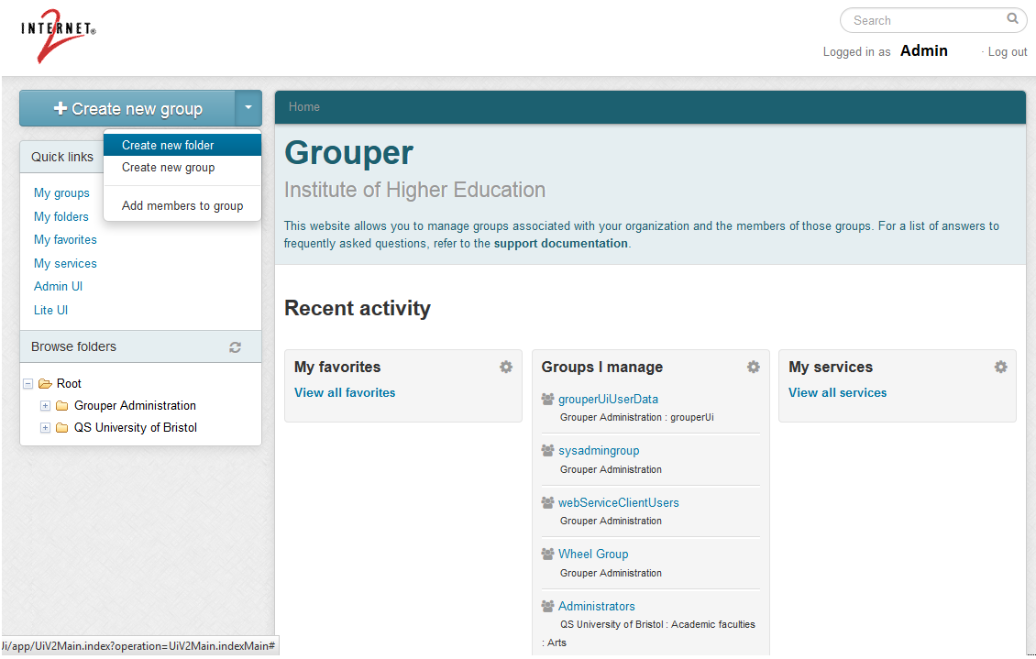
- Create a new folder that has as FolderID the FQDN of the SP to which Grouper will provide the isMemberOf attribute and the eduPersonEntitlement attribute:

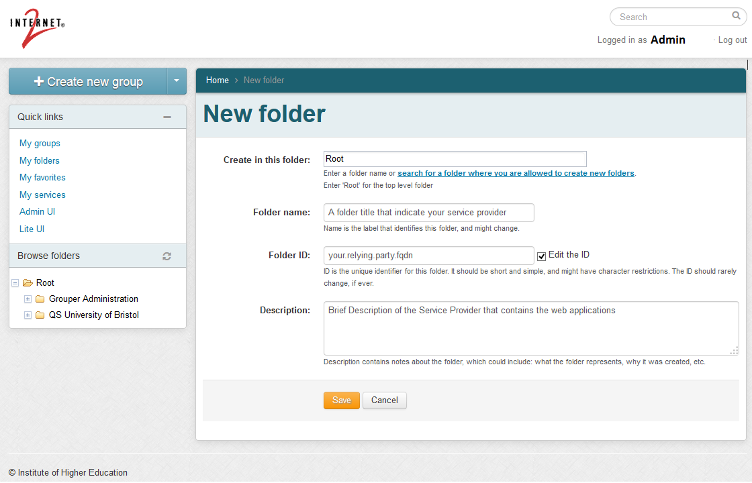
- Refresh the web page to update the visible folders.

- Move on the new folder and create another two folder
  - One, called “service”, that will be useful to quickly disable the users:

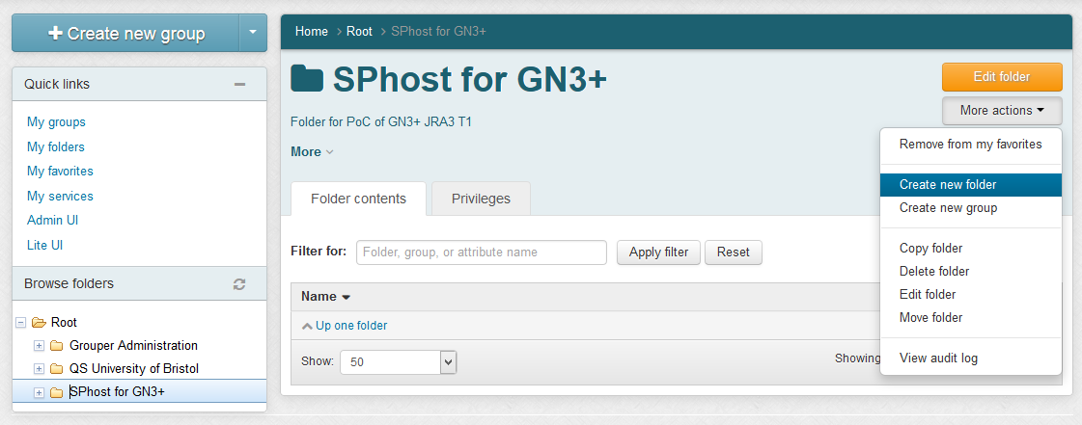
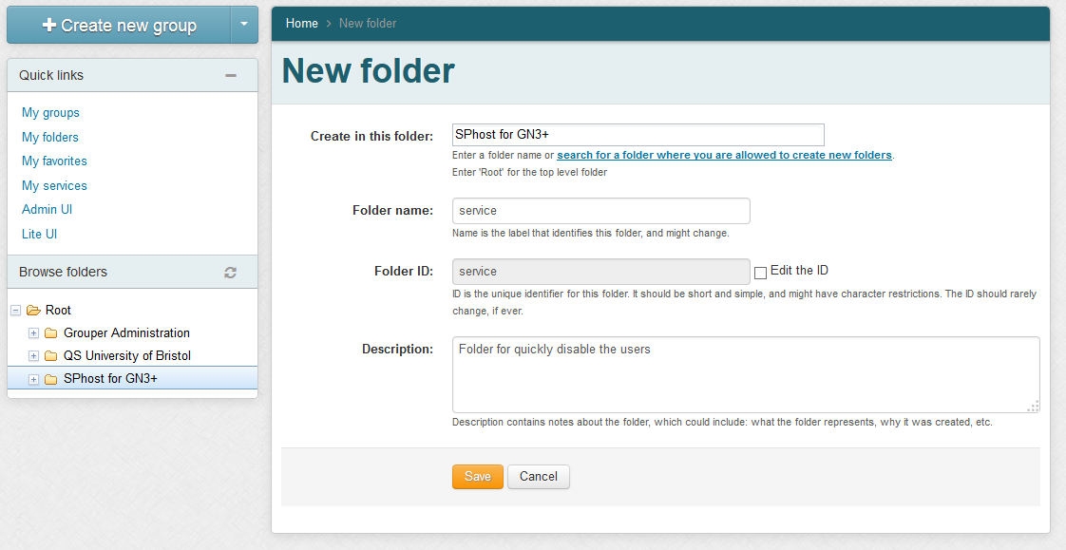
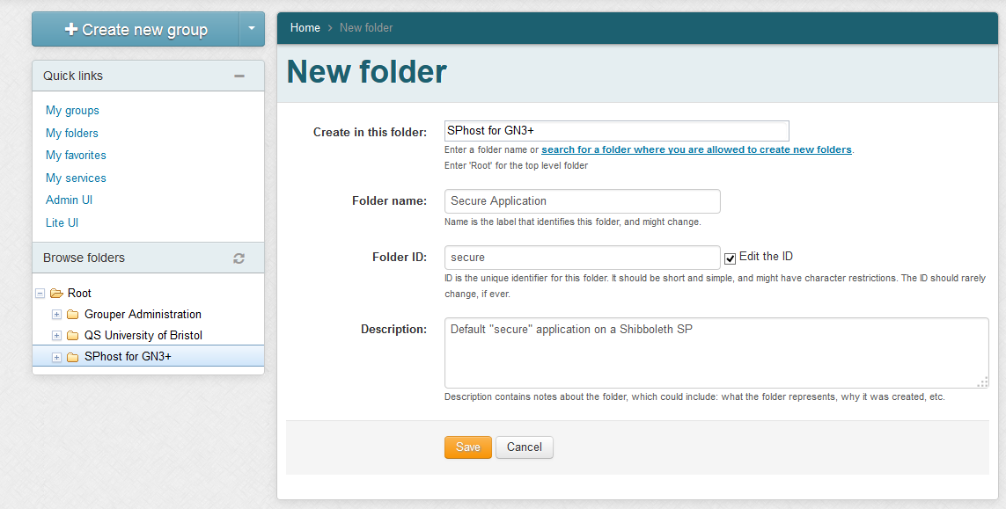
  - One, called “secure”, for Secure Application:

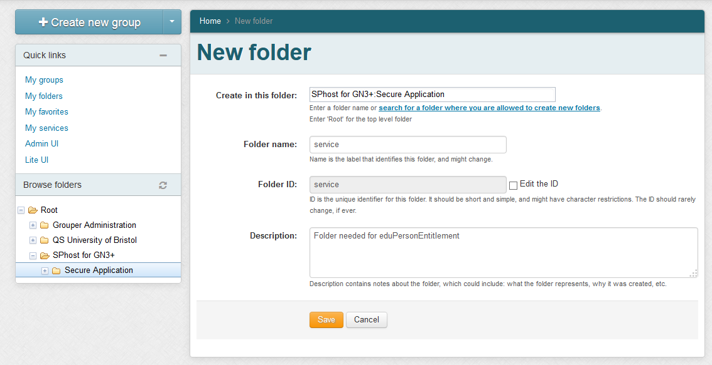
- Create another new folder called “service” into the “secure” folder:
- Create 3 new groups into the “service” folder:
  - authorized
  - blocked
  - eligible
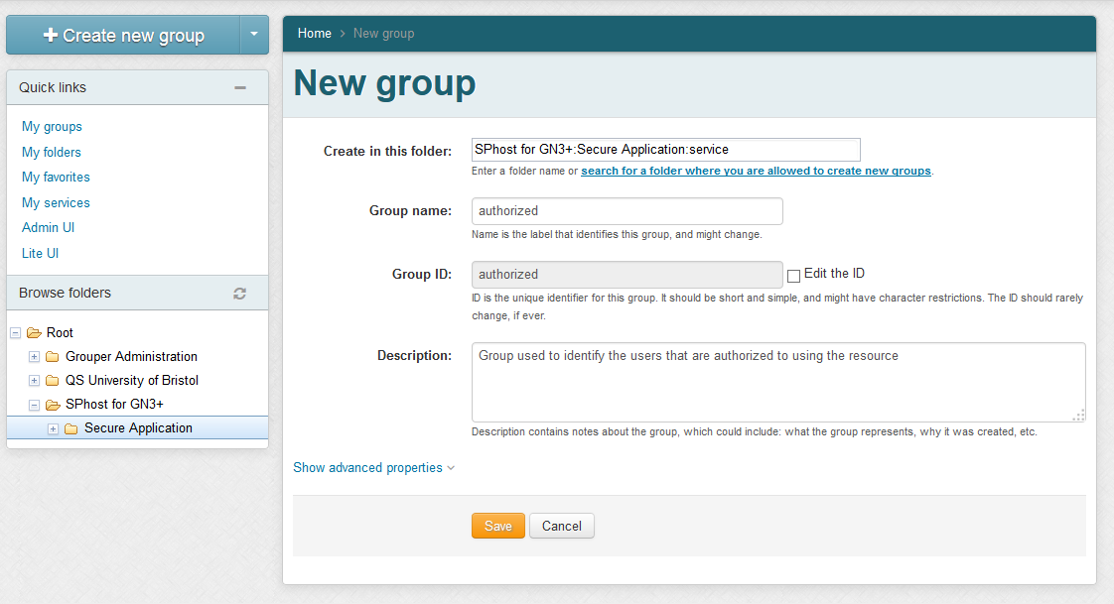

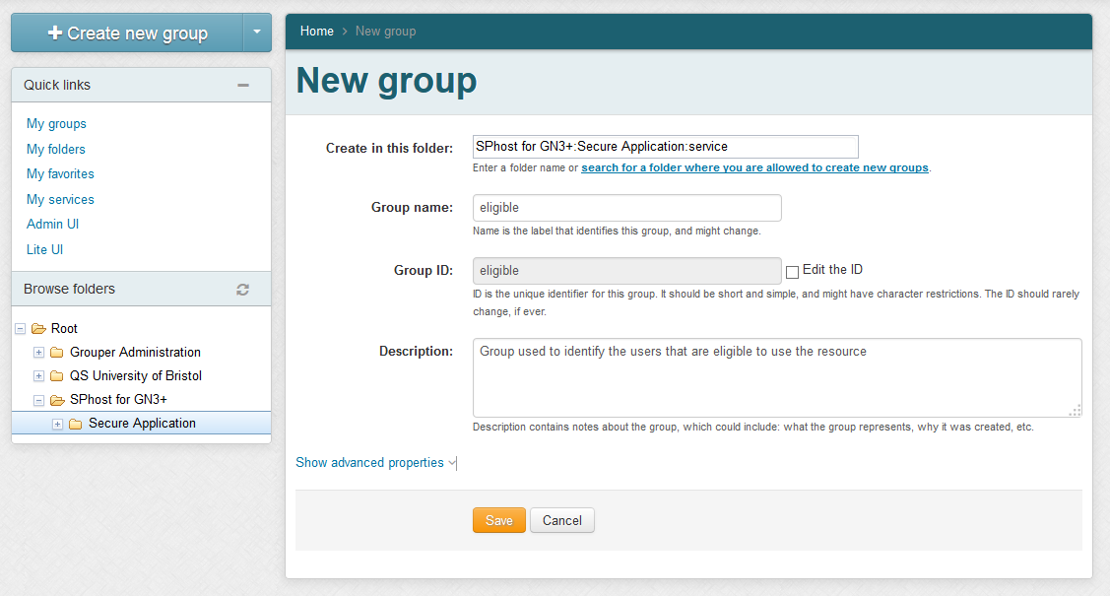
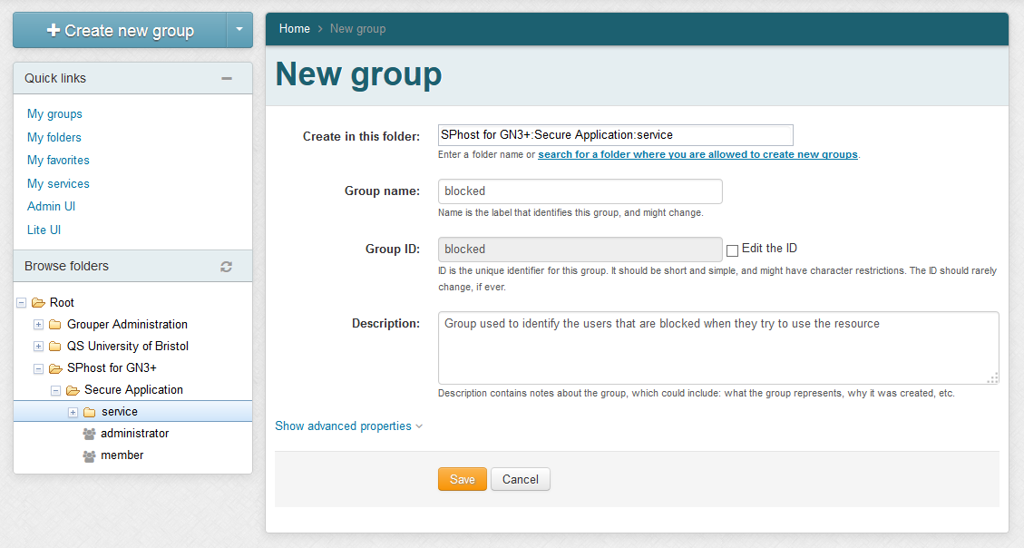

- Create a new group called “quickdisable”, in the folder “secure” of Sphost, that will contain all the users blocked on all services hosted by the SPhost relying party:
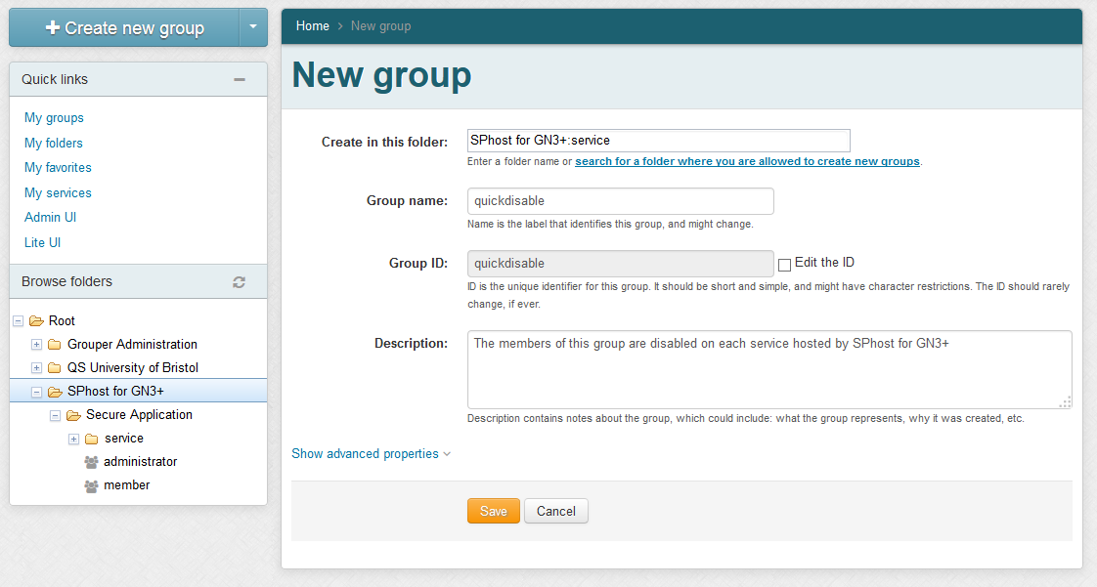
- Add the “quickdisable” group to the “blocked” group of the Secure Application:
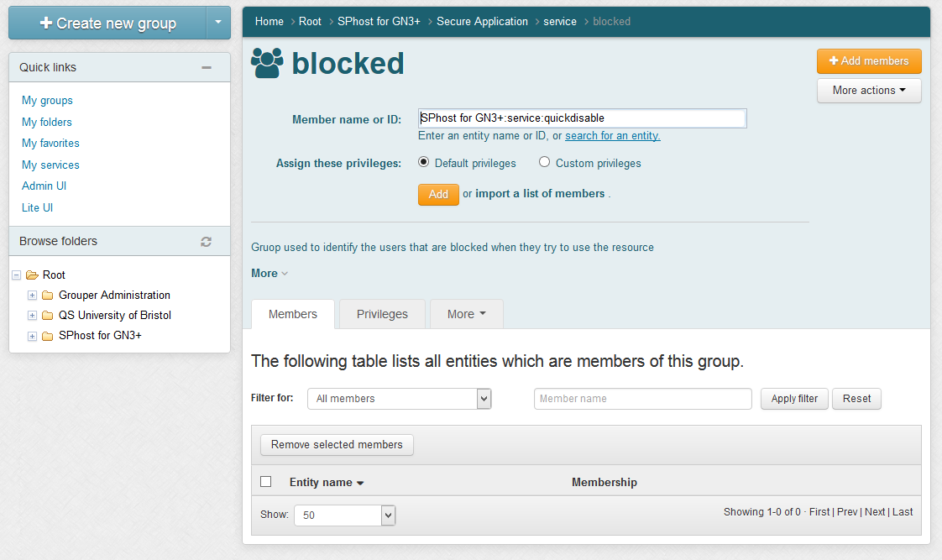
- Make the “authorized” group a composite group that involves “eligible” and “blocked” groups:
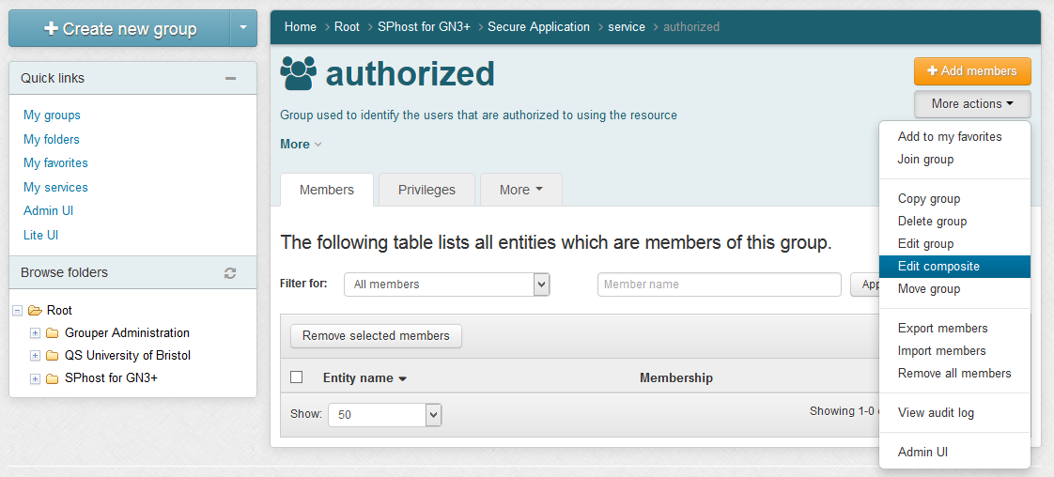
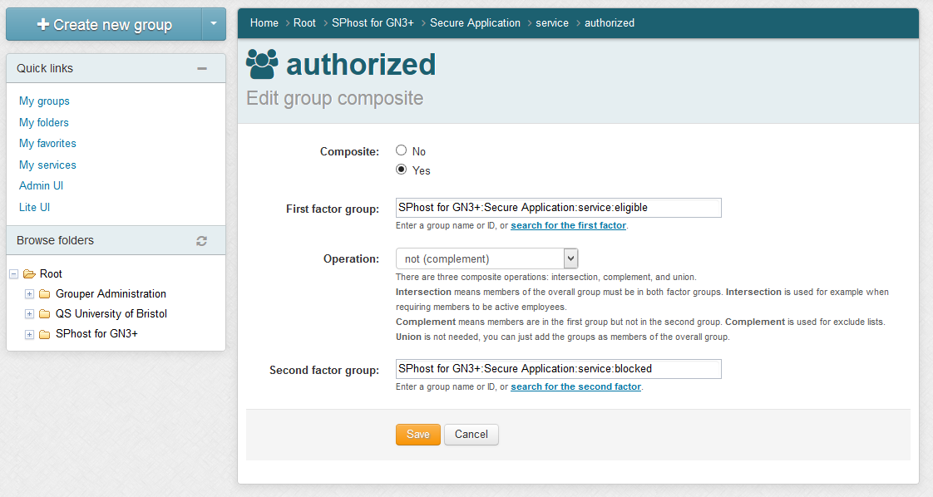

- Create the following new groups into the “secure” folder and add members by searching their surname:
  - administrator
  - member
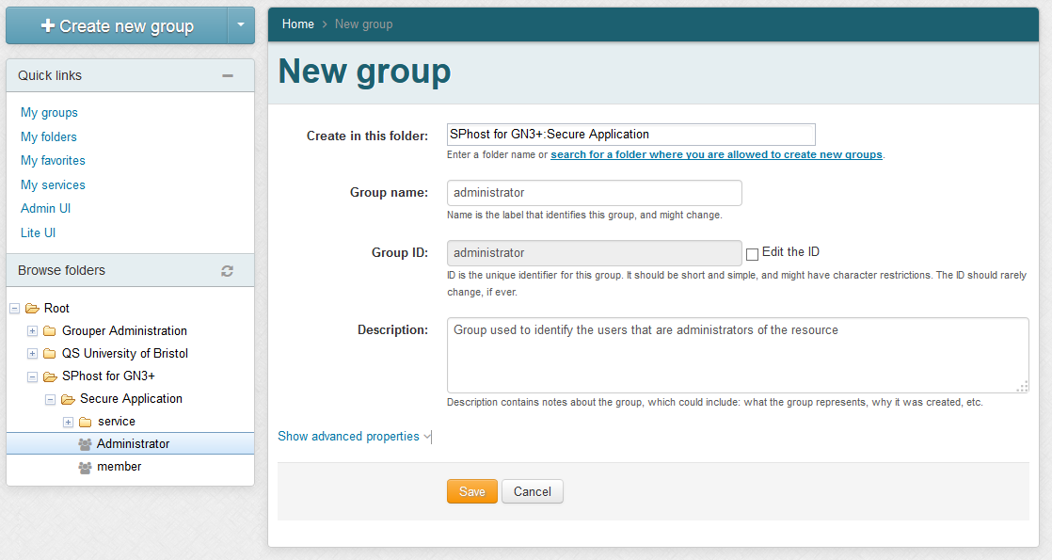
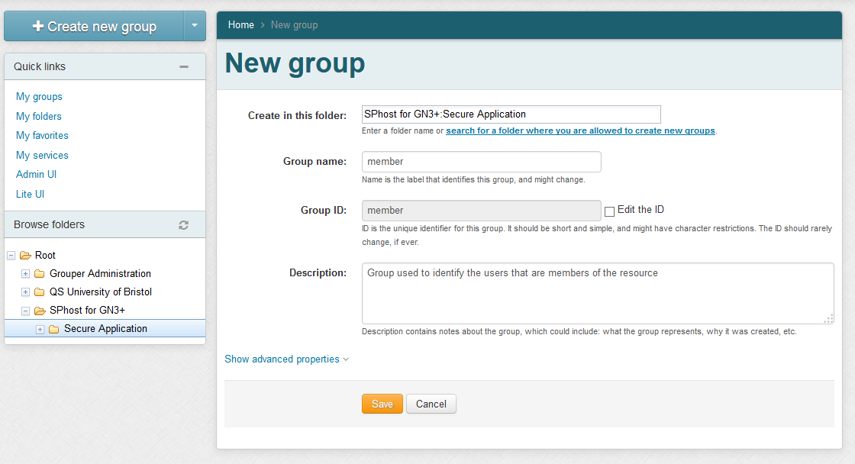
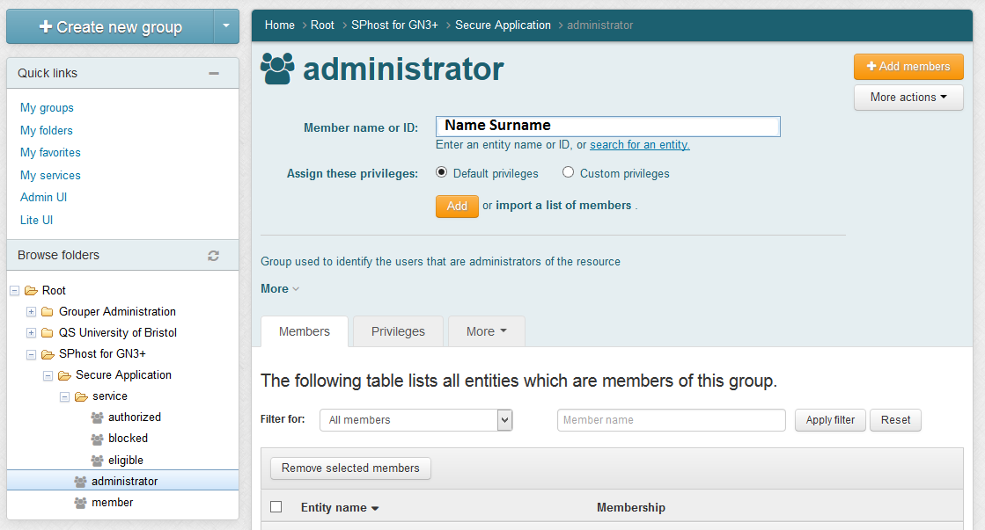
- Add the “administrator” and “member” group as member of the “eligible” group created into “service” folder of Secure Application:

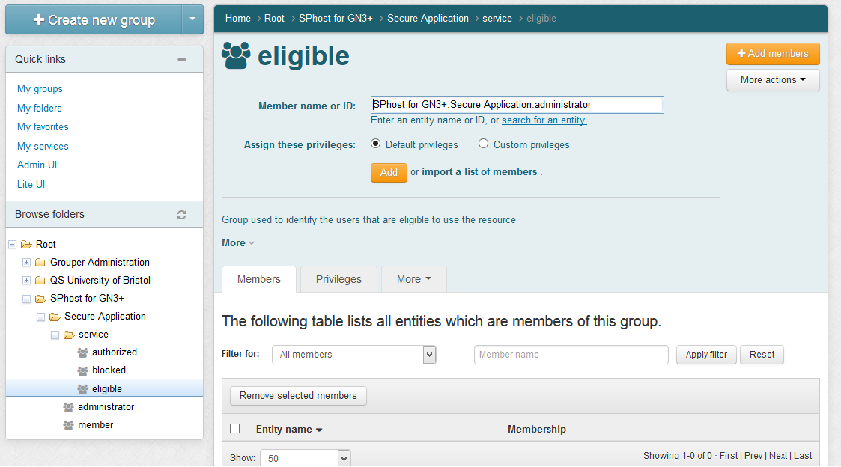

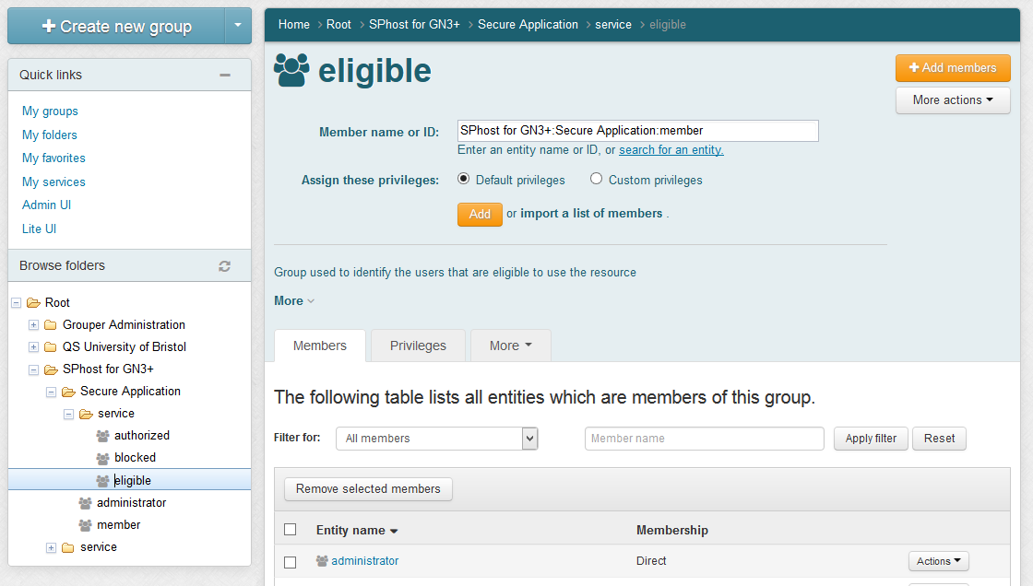
- Finally add members to the “administrator” or “member” group created.
This permits to Grouper to release the isMemberOf attribute and the eduPersonEntitlement attribute of the subjects added for your “secure” service on Grouper application.

- Try to log-in on a simple application protected by the SP for which you have created a folder into Grouper and see if the attributes “isMemberOf” and “eduPersonEntitlement” are released by checking the /Shibboleth.sso/Session page of your SP.
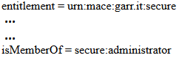
Attribute = Value

Installation of MediaWiki

Installation of MediaWiki

Requirements
- A machine with Grouper installed and configured.
- A Shibboleth SP (sp.example.it) with Apache2 Web Server, PHP 5.3.2 or later and MySQL 5.0.2 or later.
- MediaWiki plugi

MediaWiki installation
- Install the software requirements for MediaWiki on your SP:
- sudo su -
- apt-get install apache2 mysql-server php5-mysql phpmyadmin php5-intl php-apc
- Install MediaWiki on your SP:
- sudo su -
- cd /usr/local/src
- wget http://releases.wikimedia.org/mediawiki/1.23/mediawiki-1.23.6.tar.gz
- tar xzf mediawiki-1.23.6
- mv mediawiki-1.23.6 /var/www
- vim /etc/apache2/sites-available/mediawiki.conf :
<IfModule mod_alias.c>
Alias /wiki /var/www/mediawiki-1.23.6/
<Directory /var/www/mediawiki-1.23.6/>
Options Indexes MultiViews FollowSymLinks
Order deny,allow
Allow from all
</Directory>
</IfModule>

- a2ensite mediawiki.conf ; service apache2 reload
- mysql -u root -p (type your mySQL root password to access)
  - create database wikidb;
  - grant index, create, select, insert, update, delete, alter, lock tables on wikidb.* to 'wikiuser'@'localhost' identified by '##wikiuserPassword_CHANGE_ME##';
  - flush privileges;
  - quit
- Configure MediaWiki on your SP:
- Open the page “https://sp.example.it/wiki/mw-config/index.php” and follow the instructions until the end.
- Download the “LocalSettings.php” file and put it into the MediaWiki directory (/var/www/mediawiki-1.23.6/)

Install and Configure Shibboleth plugin for MediaWiki
The following instructions are based on the page:
http://www.mediawiki.org/wiki/Extension:Shibboleth_Authentication
- Configure Shibboleth SP to support the MediaWiki authentication plugin:
- vim /etc/shibboleth/shibboleth2.xml
<Host name="sp.example.it">
<Path name="wiki" authType="shibboleth" requireSession="false"/>
</Host>
...
<SessionInitiator type="Chaining" Location="/DS" id="DS" relayState="cookie" isDefault="true">
<SessionInitiator type="SAML2" acsIndex="1" template="bindingTemplate.html"/>
<SessionInitiator type="Shib1" acsIndex="5"/>
<SessionInitiator type="WAYF" acsIndex="5" URL="https://dsc.example.it/DS"/>
</SessionInitiator>

- shibd -t /etc/shibboleth/shibboleth2.xml
- service shibd restart
- Edit the apache2 wiki configuration to support the Shibboleth authentication:
- vim /etc/apache2/sites-enabled/mediawiki.conf:
<IfModule mod_alias.c>
Alias /wiki /var/www/mediawiki-1.23.6/
<Directory /var/www/mediawiki-1.23.6/>
Options Indexes MultiViews FollowSymLinks
Order deny,allow
Allow from all
</Directory>
<Location /wiki>
AuthType shibboleth
ShibRequireSession On
require entitlement urn:mace:garr.it:wiki
</Location>
</IfModule>
(This rules require Apache 2.4 and Shibboleth SP software v2.4.3.
If you use a Shibboleth SP release >= 2.5.1, please, use this:
<Location /wiki>
AuthType shibboleth
ShibRequestSetting requireSession 1
require shib-attr entitlement urn:mace:garr.it:wiki
</Location>
)
- Copy the extension code provide by THIS PAGE into
/var/www/mediawiki-1.23.6/extensions/ShibAuthPlugin.php
- Modify the “/var/www/mediawiki-1.23.6/LocalSettings.php” by adding these lines:
# The following permissions were set based on your choice in the installer
$wgGroupPermissions['*']['edit'] = false;
# Add more configuration options below.
// Shibboleth Authentication Stuff
// Load ShibAuthPlugin
require_once('extensions/ShibAuthPlugin.php');
// Last portion of the shibboleth WAYF url for lazy sessions.
// This value is found in your shibboleth.xml file on the setup for your SP
// WAYF url will look something like: /Shibboleth.sso/WAYF/$shib_WAYF
$shib_WAYF = "DS";
// Are you using an old style WAYF (Shib 1.3)
// or new style Discover Service (Shib 2.x)?
// Values are WAYF or DS, defaults to WAYF
$shib_WAYFStyle = "DS";
// Is the assertion consumer service located
// at an https address (highly recommended)
// Default for compatibility with previous version: false
$shib_Https = true;
// Prompt for user to login
$shib_LoginHint = "Login via Single Sign-on";
// Where is the assertion consumer service located on the website?
// Default: "/Shibboleth.sso"
$shib_AssertionConsumerServiceURL = "/Shibboleth.sso";
// Map Real Name to what Shibboleth variable(s)?
# $shib_RN = ucfirst(strtolower($_SERVER['HTTP_FIRST_NAME'])) . ' '
# . ucfirst(strtolower($_SERVER['HTTP_LAST_NAME']));
$shib_RN = $_SERVER['cn'];
// Map e-mail to what Shibboleth variable?
$shib_email = $_SERVER['mail'];
// Field containing groups for the user
if (array_key_exists("isMemberOf", $_SERVER)) {
$shib_groups = $_SERVER['isMemberOf'];
}
//This value must match with the FolderID of Wiki on the Grouper instance
$shib_group_prefix = "wiki";
// The ShibUpdateUser hook is executed on login.
// It has two arguments:
// - $existing: True if this is an existing user, false if it is a new user being added
// - &$user: A reference to the user object.
// $user->updateUser() is called after the function finishes.
// In the event handler you can change the user object, for instance set the email address or the real name
// The example function shown here should match behavior from previous versions of the extension:
$wgHooks['ShibUpdateUser'][] = 'ShibUpdateTheUser';
function ShibUpdateTheUser($existing, $user) {
global $shib_email;
global $shib_RN;
if (! $existing) {
if($shib_email != null)
$user->setEmail($shib_email);
if($shib_RN != null)
$user->setRealName($shib_RN);
}
}
// This is required to map to something
// You should beware of possible namespace collisions, it is best to chose
// something that will not violate MW's usual restrictions on characters
// Map Username to what Shibboleth variable?
$shib_UN = ucfirst(strtolower($_SERVER['eppn']));
// Shibboleth doesn't really support logging out very well. To take care of
// this we simply get rid of the logout link when a user is logged in through
// Shib. Alternatively, you can uncomment and set the variable below to a link
// that will either clear the user's cookies or log the user out of the Idp and
// instead of deleting the logout link, the extension will change it instead.
$shib_logout = "/Shibboleth.sso/Logout";
//Add to permit the management of the User rights
$wgUserrightsInterwikiDelimiter = '#';
// Activate Shibboleth Plugin
SetupShibAuth();

- Modify the value “protected mRemember” to “var mRemember” into the “/var/www/mediawiki-1.23.6/includes/specials/SpecialUserlogin.php” file.
- Modify the “attribute-filter.xml” of your Identity Provider and restart its Tomcat server to release the attributes “commonName”, “eduPersonPrincipalName” and “mail” to this SP.

Integrate MediaWiki with Grouper

Add the MediaWiki groups to Grouper
- Open Grouper application, log-in as Admin and create the folder for the WiKi (“WiKi of MediaWiki” with Folder ID = “wiki”) under the relying party's folder:
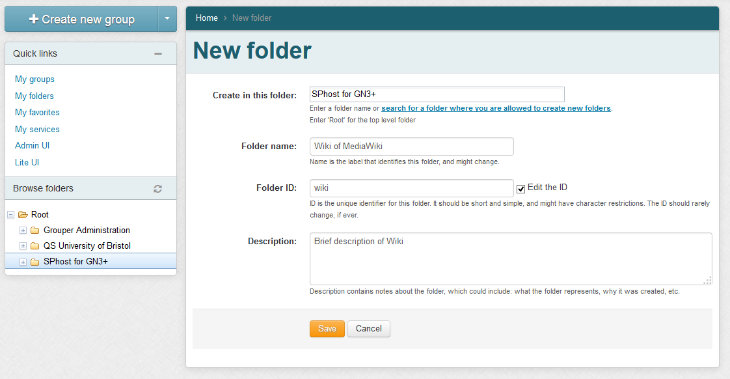

- Create the “service” folder into the “wiki” folder and add to it these groups:
  - authorized group:
    - Name: auhtorized
    - ID: authorized
    - Description: Group used to identify the users that are authorized to use the Wiki
  - eligible group:
    - Name: eligible
    - ID: eligible
    - Description: Group used to identify the users that are eligible to use the Wiki
  - blocked group:
    - Name: blocked
    - ID: blocked
    - Description: Group used to identify the users that are blocked when they try to use the Wiki
- Make the “authorized” group a composite group that involves “eligible” and “blocked” groups:
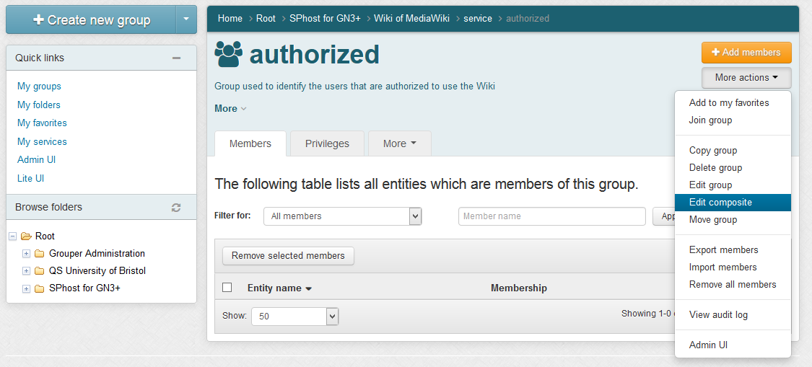

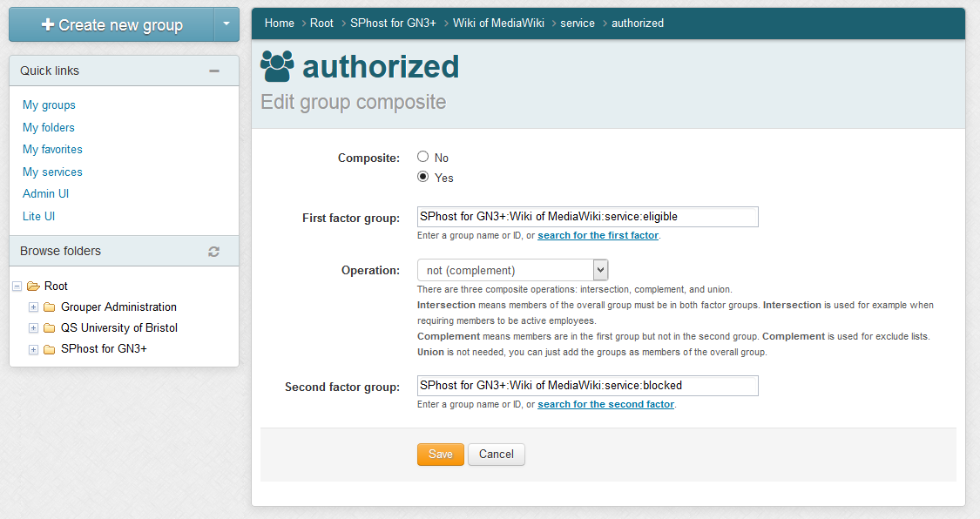
- Add the group designed to contain the users that are blocked on all services hosted by the SP to the “blocked” group:
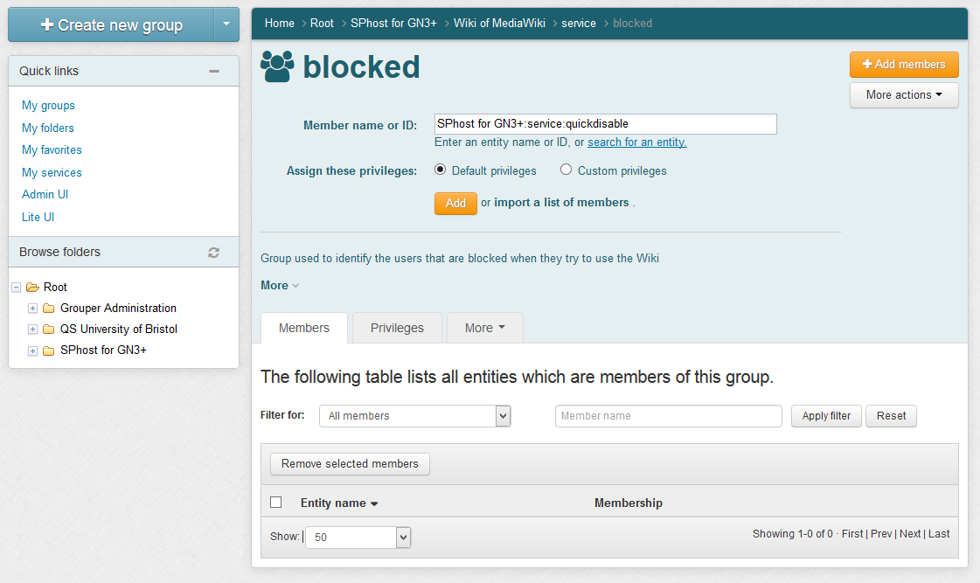
- Into the main “wiki” folder create these new groups:
  - Administrators Group:
    - Name: Administrators Group
    - ID: sysop
    - Description: Brief description of Administrators Group
  - Bureaucrats Group:
    - Name: Bureaucrats Group
    - ID: bureaucrat
    - Description: Brief description of Bureaucrats Group
  - Users Group:
    - Name: Users Group
    - ID: user
    - Description: Brief description of Users Group
(each ID value matches with the default groups of MediaWiki software and stored into its DB)

- Add the new groups created to the “eligible” group of “wiki”, for example:
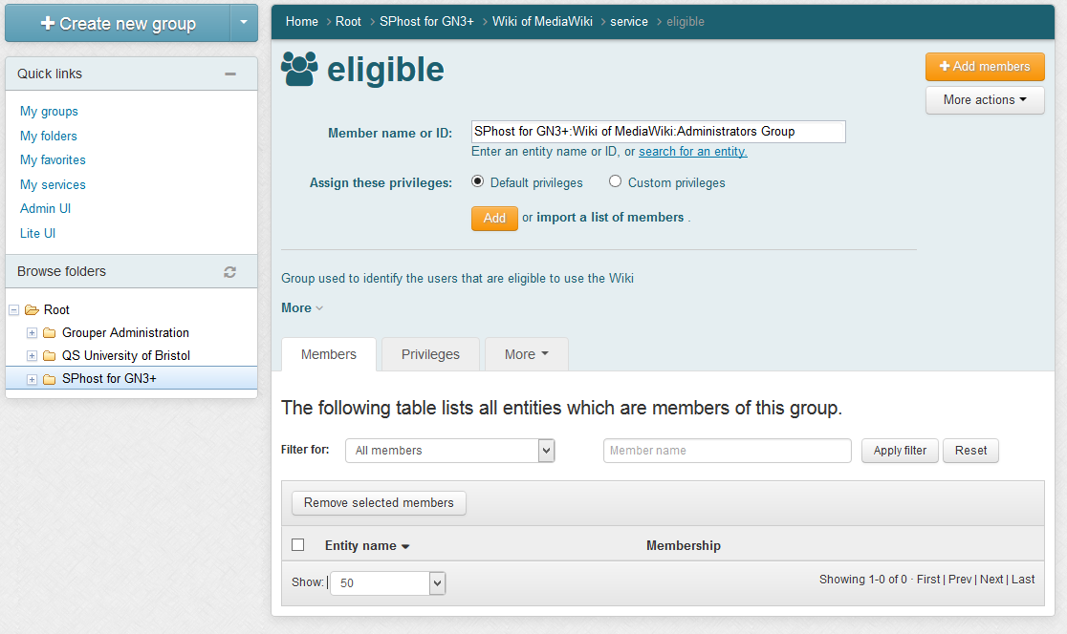
- Add the members that you want elevate to administrators of Wiki to the Administrators Group and to Bureaucrats Group. See the example below.
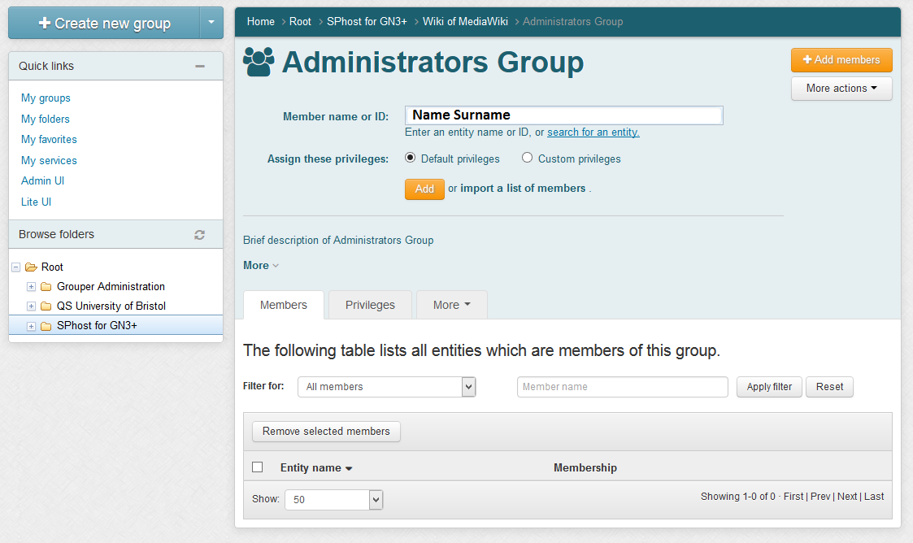
- Try to access into the Wiki and navigate through the special pages to understand if your user is administrator or not.
If you are Administrator of the Wiki, you can find the page “User Rights Management” between the special pages.

Add new MediaWiki groups and link them to Grouper
- Modify the “/var/www/mediawiki-1.23.6/LocalSettings.php” by adding these lines:
// New GN3+ group and its permissions
$wgGroupPermissions['GN3+']['move'] = true;
$wgGroupPermissions['GN3+']['move-subpages'] = true;
$wgGroupPermissions['GN3+']['move-rootuserpages'] = false;
$wgGroupPermissions['GN3+']['movefile'] = true;
$wgGroupPermissions['GN3+']['read'] = true;
$wgGroupPermissions['GN3+']['edit'] = true;
$wgGroupPermissions['GN3+']['createpage'] = true;
$wgGroupPermissions['GN3+']['createtalk'] = true;
$wgGroupPermissions['GN3+']['writeapi'] = false;
$wgGroupPermissions['GN3+']['upload'] = true;
$wgGroupPermissions['GN3+']['reupload'] = true;
$wgGroupPermissions['GN3+']['reupload-shared'] = true;
$wgGroupPermissions['GN3+']['minoredit'] = true;
$wgGroupPermissions['GN3+']['purge'] = false;
$wgGroupPermissions['GN3+']['sendemail'] = false;
// Activate Shibboleth Plugin
SetupShibAuth();
(Each line defines each permission that the “GN3+” group will have. See the MediaWiki User Rights [2])
- Move on your Grouper instance and:
  - Create this new GN3+ group under the “wiki” folder:
    - Name: GN3+ Group
    - ID: GN3+
    - Description: Brief description of GN3+ Group
(the value of “ID” must match with the name of the new MediaWiki group)
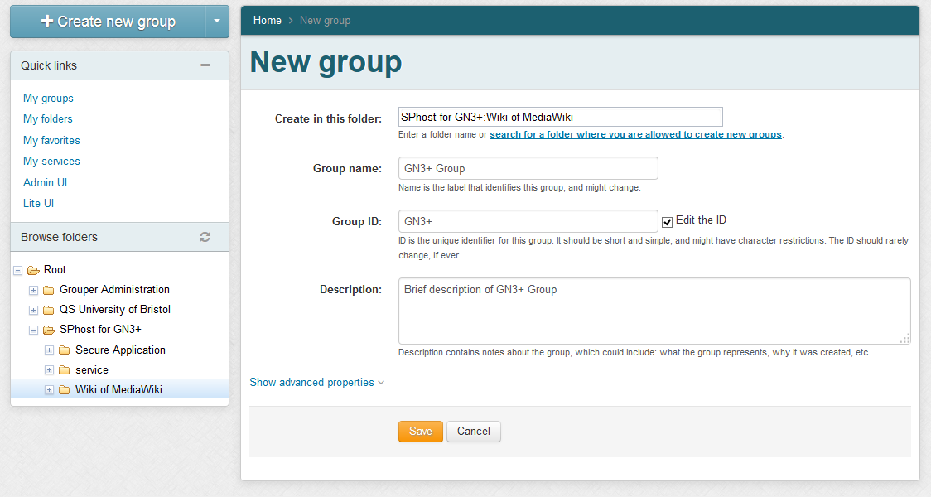

  - Add the members that you want to be part of this new GN3+ group.
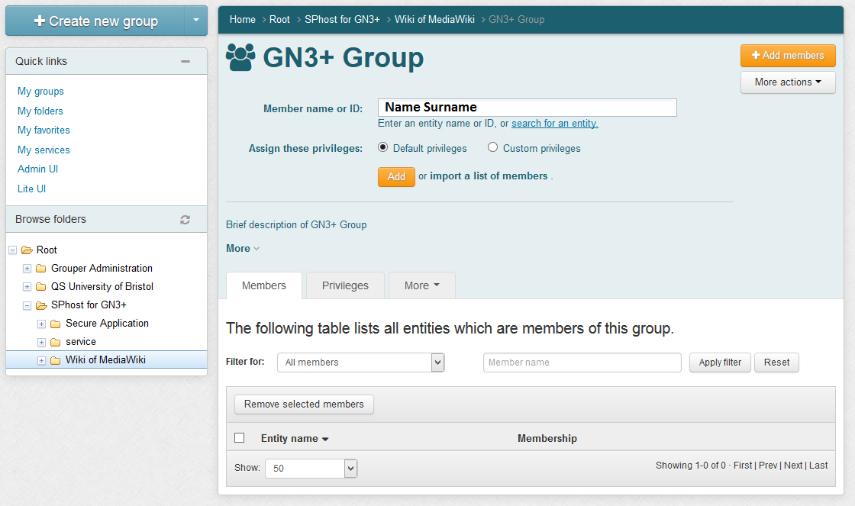
  - Add the new “GN3+” group to the “eligible” group under “service” folder:
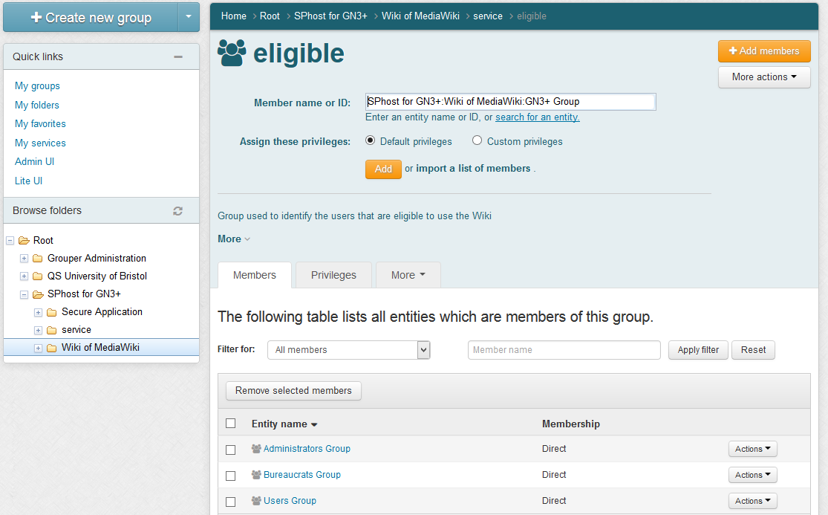
- Access to the Wiki and navigate through the special page “User group rights” and find the new MediaWiki group called “GN3+”.
- Verify that the GN3+ group has all its members by open the link called “(list of members)”.

How to protect wiki with a lazy session
- Modify the “mediawiki.conf”:
- vim /etc/apache/site-enabled/mediawiki.conf:
<IfModule mod_alias.c>
Alias /wiki /var/www/mediawiki-1.23.6/
<Directory /var/www/mediawiki-1.23.6/>
Options Indexes MultiViews FollowSymLinks
Order deny,allow
Allow from all
</Directory>
<Location /wiki>
AuthType shibboleth
require shibboleth
</Location>
<Location /wiki/login.php>
AuthType shibboleth
ShibRequireSession On
require entitlement urn:mace:garr.it:wiki
</Location>
</IfModule>

- Create the “login.php” file:
<?php
$target = isset($_GET['target']) ? $_GET['target'] : '/';
header('Location: '.$target);
die();
?>

- Modify the “LocalSettings.php” into this way:
$shib_WAYFStyle = "CustomLogin";
…
$shib_AssertionConsumerServiceURL = $wgScriptPath."/login.php";

Installation of Moodle

Installation of Moodle

Requirements
- A machine with Grouper installed and configured.
- A Shibboleth SP (sp.example.it) with Apache2 Web Server, PHP 5.3.3 or later, MySQL 5.1.33
or later and Ghostscript for pdf annotation.

Moodle Installation
Install and Configure Moodle on your Service Provider
- Install the software requirements for Moodle on your SP:
- sudo apt-get install apache2 mysql-server php5-mysql ghostscript php5-curl php5-xmlrpc php5-intl php-pear php5-dev php5-gd
- Install Moodle 2.6.6 on your SP:
- sudo su -
- cd /usr/local/src
- wget https://download.moodle.org/download.php/direct/stable26/moodle-2.6.6.tgz
- tar xzf moodle-latest-26.tgz
- mv moodle/ /var/www/
- chown -R root:root /var/www/moodle ; chown www-data /var/www/moodle
- vim /etc/apache2/sites-available/moodle.conf :
<IfModule mod_alias.c>
Alias /moodle /var/www/moodle/
<Directory /var/www/moodle/>
Options Indexes MultiViews FollowSymLinks
Order deny,allow
Allow from all
</Directory>
</IfModule>
- a2ensite moodle.conf ; service apache2 reload
- mysql -u root -p (type your mySQL root password to access)
  - create database moodledb;
  - create user 'moodledbuser'@'localhost' identified by '##moodledbuserPassword_CHANGE_ME##';
  - grant all on moodledb.* to 'moodledbuser'@'localhost' identified by '##moodledbuserPassword_CHANGE_ME##';
  - flush privileges;
  - quit
- Create the “moodledata” directory with right permissions:
- sudo mkdir /var/moodledata ; chown www-data:www-data /var/moodledata

- Configure Moodle on your SP:
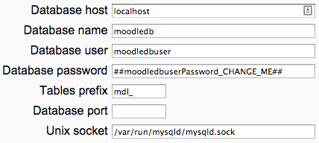
- Open the page “https://sp.example.it/moodle/install.php” and follow the instructions until the end. (Remember that you have installed a MySQL Database and ignore the Environment Check message about OpCache)
For default, MySQL installs its socket to: /var/run/mysqld/mysqld.sock
Pay attention on the credential of Admin User that you will give to Moodle installation.
- At the end of the Moodle installation you will be redirect on the Moodle learning platform logged-in as Administrator.
- Create the cron rule necessarily to Moodle:
- Add this line to the file opened with `crontab -e`:
*/5 * * * * /usr/bin/php -c /etc/php5/apache/php.ini /var/www/moodle/admin/cli/cron.php

Install and Configure Shibboleth plugin for Moodle
The following instructions are based on the README.txt you can find into the directory:
/var/www/moodle/auth/shibboleth
- Configure Shibboleth SP to support the Moodle authentication plugin:
- vim /etc/shibboleth/shibboleth2.xml
<Host name="sp.example.it">
<Path name="moodle" authType="shibboleth" requireSession="true"/>
<Path name="auth/shibboleth/index.php" authType="shibboleth" requireSession="false"/>
</Host>
<SessionInitiator type="Chaining" Location="/DS" id="DS" relayState="cookie" isDefault="true">
<SessionInitiator type="SAML2" acsIndex="1" template="bindingTemplate.html"/>
<SessionInitiator type="Shib1" acsIndex="5"/>
<SessionInitiator type="WAYF" acsIndex="5" URL="https://dsc.example.it/DS"/>
</SessionInitiator>

- shibd -t /etc/shibboleth/shibboleth2.xml
- service shibd restart
- Edit the apache2 moodle configuration to support the Shibboleth authentication:
- vim /etc/apache2/sites-enabled/moodle.conf
<IfModule mod_alias.c>
Alias /moodle /var/www/moodle/
<Directory /var/www/moodle/>
Options Indexes MultiViews FollowSymLinks
Order deny,allow
Allow from all
</Directory>
<Directory /var/www/moodle/auth/shibboleth/index.php>
AuthType shibboleth
ShibRequireSession On
require entitlement urn:mace:garr.it:moodle
</Directory>
</IfModule>

(This rules require apache 2.4 and Shibboleth SP software v2.4.3.
If you use a Shibboleth SP release >= 2.5.1, please, use this:
<Directory /var/www/moodle/auth/shibboleth/index.php>
AuthType shibboleth
ShibRequestSetting requireSession 1
require shib-attr entitlement urn:mace:garr.it:moodle
</Directory>
)
- service apache2 restart
- As Moodle admin, go to the Site administration => Plugins => Authentication => Manage authentication and click on the Shibboleth “Settings”.
- Fill in the fields of the form:
  - 'Username': for example “eduPersonPrincipalName” o “eppn”
  - Shibboleth Service Provider logout handler URL: “/Shibboleth.sso/Logout”
  - 'First name': for example “givenName”
  - 'Surname': for example “sn”
  - 'Email address': for example “mail”
If you want that Moodle checks these value on each User Login, you must select the “On every Login”
value from the listbox near the “Update local”.
The fields should contain the name of the Shibboleth attributes that you want to map onto the
corresponding Moodle variable (refer the Shibboleth documentation or the documentation of your Shibboleth federation for information about the attributes that are available from IdPs that the Moodle learning platform must serve).
Shibboleth Attributes needed by Moodle:
For Moodle to work properly Shibboleth should at least provide the attribute that is used as username in Moodle. It has to be unique for all Shibboleth.
Be aware that Moodle converts the username to lowercase.
So, the overall behaviour of the username will be case-insensitive.
All attributes used for moodle must obey a certain length. You can find this value by searching the word “maxlength”. For example on the “signup_form.php” file:
$mform->addElement('text', 'username', get_string('username'), 'maxlength="100" size="12"');
$mform->addElement('passwordunmask', 'password', get_string('password'), 'maxlength="32" size="12"');
$mform->addElement('text', 'email', get_string('email'), 'maxlength="100" size="25"');
$mform->addElement('text', 'email2', get_string('emailagain'), 'maxlength="100" size="25"');
$mform->addElement('text', $field, get_string($field), 'maxlength="100" size="30"');
$mform->addElement('text', 'city', get_string('city'), 'maxlength="120" size="20"');
Especially the 'Username' field is of great importance because this attribute is used for the Moodle authentication of Shibboleth users.
- Save the changes with button “Save changes”.

- When all is ready, enable the Shibboleth authentication by pressing on the “eye” into the “Enable” column for Shibboleth.
- The last things to do is modify the Site administration => Plugins => Authentication => Manage authentication => “Instruction” blank space by putting some information like these:

If you do not have credentials to enter this Moodle site, you can use your federated identities by clicking the link below.
Where the Shibboleth image is linked to the page: https://sp.example.it/moodle/auth/shibboleth/index.php

Integrate Moodle with Grouper

Install and Configure the Moodle enrolment plugin for VOOT
- Download the enrolment plugin into the properly directory:
- cd /var/www/moodle/enrol
- git clone https://github.com/biancini/moodle-enrol_voot.git
- mv moodle-enrol_voot/ voot/
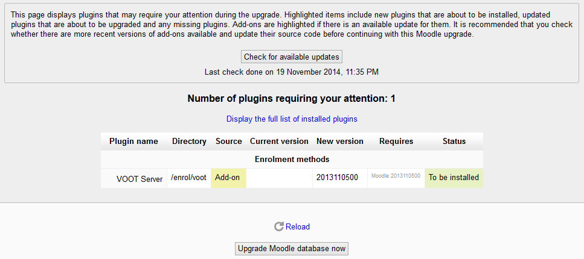
- Open a new windows of your browser and go to the “Site administration”=>”Notifications” to see which plugin require to be installed and press on “Upgrade Moodle database now”:
- Configure the settings for “VOOT Server” like this:
- VOOT host: grouper.full.qualified.domain.name
- VOOT user name: GrouperSystem
- VOOT password: yourGrouperSystemPassword
- Group prefix for courses: sp.example.it:moodle:
- Group name for teachers: admin
pay attention because the fields are case sensitive!
- Save the changes with the proper button and go to the Site administration => Plugins => Enrolments => Manage enrol plugins and enable the VOOT Server plugin by pressing on the “eye” into the “Enable” column.
- Add one test course with one test member for Moodle to Grouper by following the Chapter 4
- Now press on “Test settings” to verify the correct working of VOOT Server plugin.
- It is important to understand that Moodle need to know the users before their addition to the courses, so the users must login to Moodle Platform at least one time or the VOOT sync script will give, for example, the error: error: skipping unknown user username 'example@eppn.it' in course 'philo'
- Create the cron rule necessarily to sync the course stored on Grouper:
- Add this line to the file opened with `crontab -e`:
*/5 * * * * /usr/bin/php -c /etc/php5/apache/php.ini /var/www/moodle/enrol/voot/cli/sync.php

Add the Moodle groups to Grouper
- Open Grouper application, log-in as Admin and create the folder for Moodle (“Moodle Platform” with Folder ID = “moodle”) under the relying party's folder:
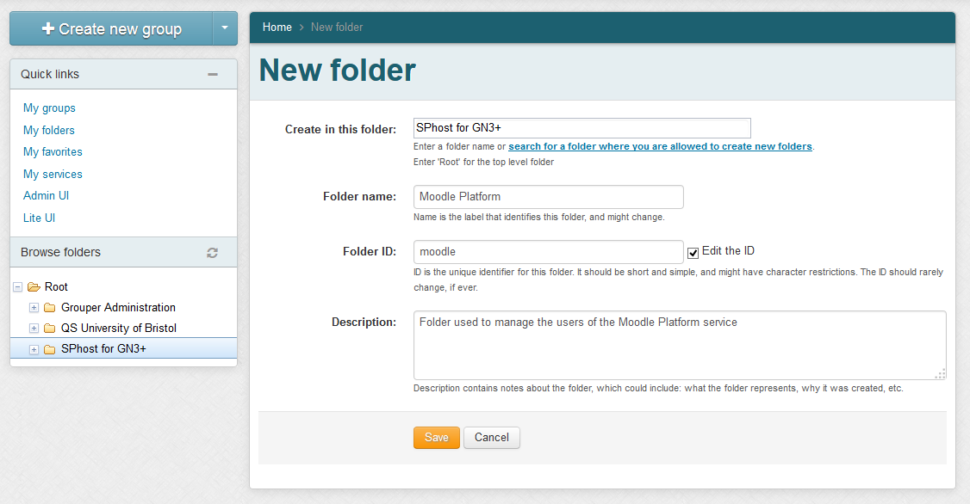
- Create the “service” folder into the new “moodle” folder and add to it these groups:
  - authorized group:
    - Name: auhtorized
    - ID: authorized
    - Description: Group used to identify the users that are authorized to use the Moodle Platform
  - eligible group:
    - Name: eligible
    - ID: eligible
    - Description: Group used to identify the users that are eligible to use the Moodle Platform
  - blocked group:
    - Name: blocked
    - ID: blocked
    - Description: Group used to identify the users that are blocked when they try to use the Moodle Platform
- Make the “authorized” group a composite group that involves “eligible” and “blocked” groups:
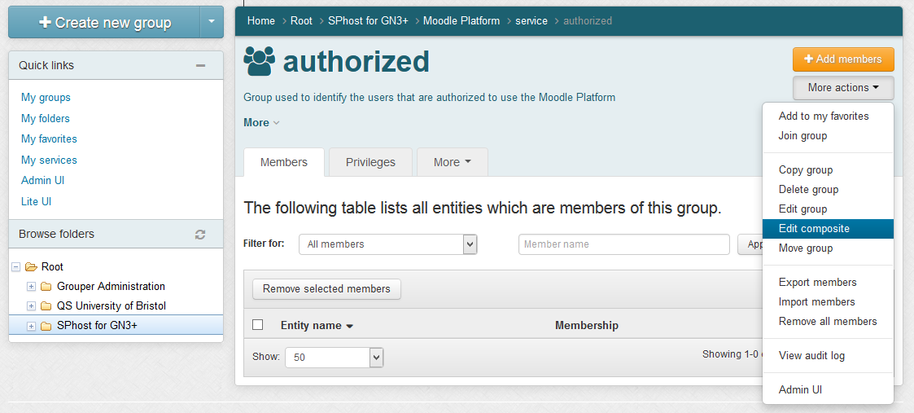
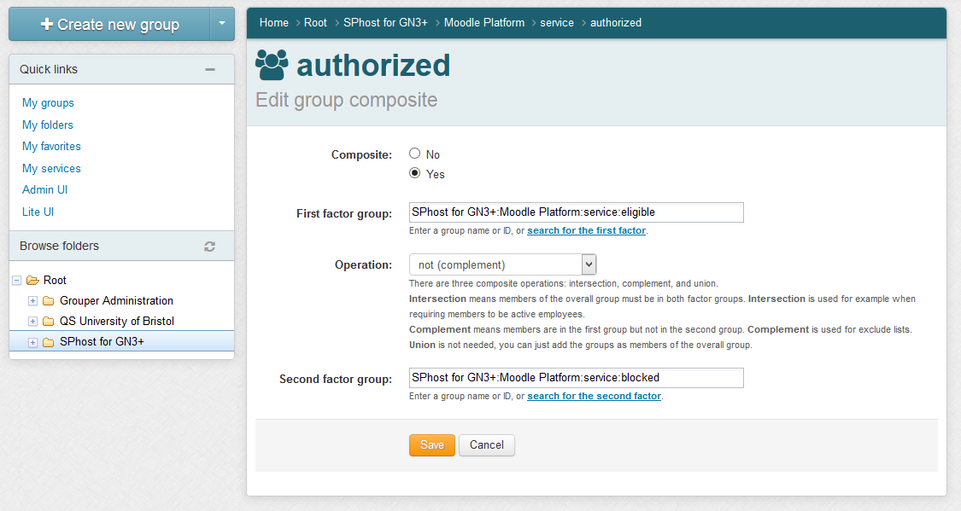

- Add the group designed to contain the users that are blocked on all services hosted by the SP to the “blocked” group:
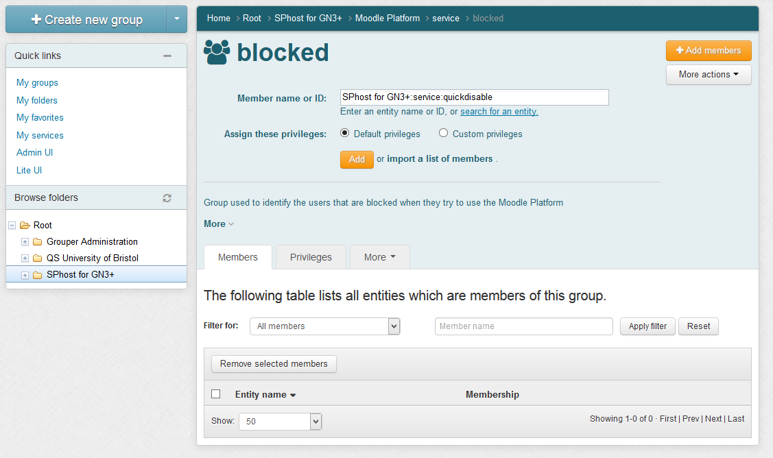
- Into the main “moodle” folder create these groups:
  - Computer Science Course:
    - Name: Computer Science Course
    - ID: computer
    - Description: Brief description of Computer Science Course
  - Mathematics Course
    - Name: Mathematics Course
    - ID: mate
    - Description: Brief description of Mathematics Course
  - Philosophy and Modern Languages Course
    - Name: Philosophy and Modern Languages Course
    - ID: philo
    - Description: Brief description of Philosophy and Modern Languages Course
- Add all members that you want on the proper group and, in the same time, assign their privileges:
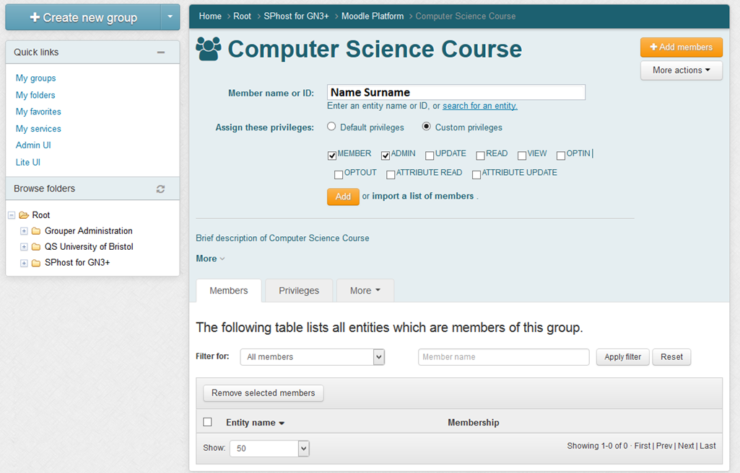

- Wait at least 5 minutes, to permit to the cron scripts to be executed, and try to access into the Moodle site with one member and navigate through the courses pages to understand if your user is administrator or not.
If you are administrator of a Moodle course you can find, into its “Administration” => “Course administration” => “Users”, the “Permissions” voice.

Conclusions
In this document the step by step operations to reproduce the PoC have been describe. With this guide it should be easily possible to replicate all the activities realized within this task activities.

References
[eduGAINjoining] Options for Joining eduGAIN. GN3plus Document Code: GN3PLUS13-642-16
[SAMLOverview] SAML Security Assertion Markup Language, http://www.oasis-open.org/committees/security
[UseCases] Enabling Users use-cases
https://intranet.geant.net/SA5 T5/SitePages/AAIforUserCommunities.asp
[Feasibility] Deliverable 321: Possibilities for Grouper in a cross/inter organizational use: Feasibility Report
[Grouper] http://www.internet2.edu/products-services/trust-identity-middleware/grouper/

Glossary
AA Attribute Authority. A server acting as an Attribute Authority role as defined in SAML 2.0 specification, cf. [SAMLOverview] SAML Security Assertion Markup Language, http://www.oasis-open.org/committees/security
AAI Authentication and Authorisation Infrastructure
Authentication Authentication is the act of confirming the truth of an attribute of a single piece of data or entity (the user of an application, for instance).
Authorization Authorization is the function of specifying access rights to resources related to information security and computer security in general and to access control in particular.
More formally, ”to authorize” is to define an access policy.
DS Discovery Service. federation component which permit the user to select from a list the Identity Provider to be used for authentication.
eduGAIN The eduGAIN service allows Authentication and Authorisation Infrastructures to interact, enabling the sharing of data between federations and providing an interconnection framework to applications willing to provide their services, content or resources to multiple federations.
FaaS Federation-as-a-Service.
Federation Identity federation. An association of organisations that come together to exchange information as appropriate about their users and resources to enable collaborations and transactions.
IdM Identity Management systems.
IdP Identity Provider. A server acting in an Identity Provider role as defined in SAML 2.0 specifications, cf. [SAMLOverview] SAML Security Assertion Markup Language, http://www.oasis-open.org/committees/security
NREN National Research and Education Network.
REFEDS Research and Education FEDerations The mission of REFEDs is to be the voice that articulates the mutual needs of research and education identity federations worldwide, see https://refeds.org
PoC Proof of Concept, realization of a certain method or idea to demonstrate its feasibility or a demonstration in principle, whose purpose is to verify that some concept or theory has the potential of being used. A proof of concept is usually small and may or may not be complete.
SAML Security Assertion Markup Language, http://saml.xml.org/wiki/saml-wiki-knowledgebase
SP Service Provider. Service Provider. A server acting in a Service Provider role as defined in SAML 2.0 specifications, cf. [SAMLOverview].
WebSSO Web Single Sign-On.

