WFO RAG agent and LLM integration
- Name and Organisation: Peter Boers, SURF
- Title: Workfloworchestrator (WFO) RAG agent and LLM integration
Rationale:
A RAG agent (short for Retrieval-Augmented Generation agent) is a type of AI application that combines natural language processing (NLP) and large language models (LLMs) with external knowledge retrieval mechanisms. This approach is particularly useful when interacting with complex systems like OSS (Operations Support Systems) and BSS (Business Support Systems) platforms, as it allows the agent to provide accurate, contextualized, and up-to-date responses. In this case we would like to create an implementation that is integrated into the workflow orchestrator so that the user of the orchestrator can use natural language also known as “prompts” to interact with the orchestration engine.
Key Components of a RAG Agent:
a . Language Model (LLM): The core of the agent, responsible for interpreting natural language queries, generating responses, and facilitating interaction.
b . Retrieval Mechanism: This connects the agent to external data sources like databases, APIs, or documents. The agent retrieves relevant information to answer questions or execute tasks.
c. Integration Layer: Manages the communication between the language model, the retrieval system, and the external platform (in this case, OSS/BSS).
How is a RAG developed
When creating a RAG, the developer prompts the chosen LLM with detailed instructions about what the tool supports. A RAG does not restrict the LLM choice as this is up to the user, however in this project we will only support the use of OpenAI API compatible LLM’s. Users can choose whether they use self-hosted LLM’s or online cloud-based offerings. It is relatively easy to start small and add functionality to a RAG, as you do not need to train an AI model. At most you may need to generate the embeddings necessary for the LLM to be able to search the available data. This is a well-documented and standardised process.

The following diagram shows at a high-level the interaction that happens when a user asks a question. As you can see it is not necessary to train an AI model, the LLM is used to help extract and enhance data retrieved from a database (in this case a vector store).
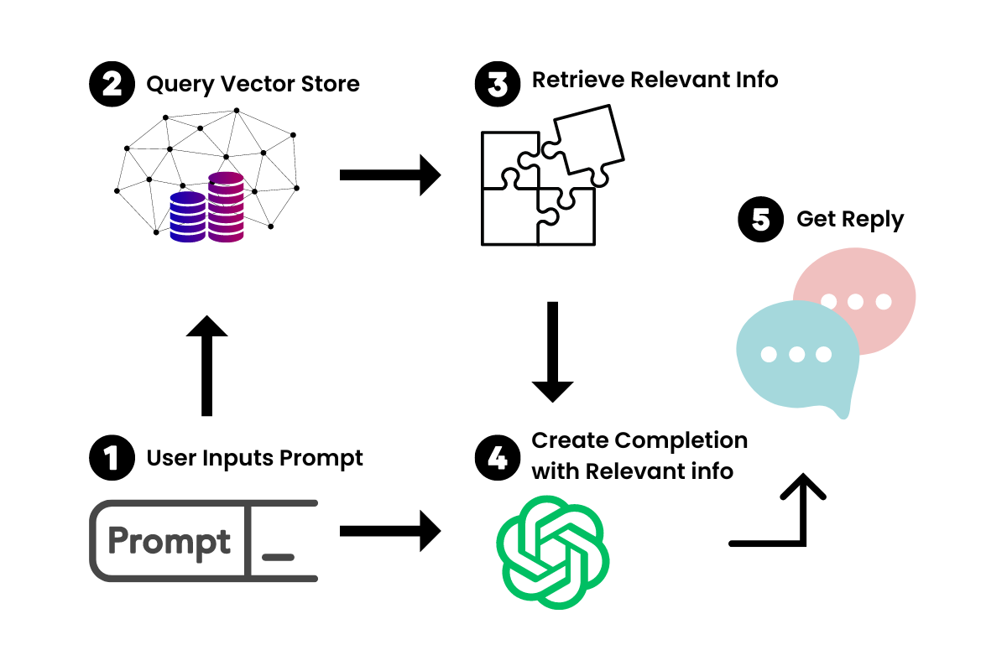

At step 3 in the process RAG frameworks like (Pydantic AI and/or LangChain) enable developers to add so called tools that can add extra functionality.

The next diagram shows how a RAG framework interacts with a tool to enrich the data that is retrieved from a database.

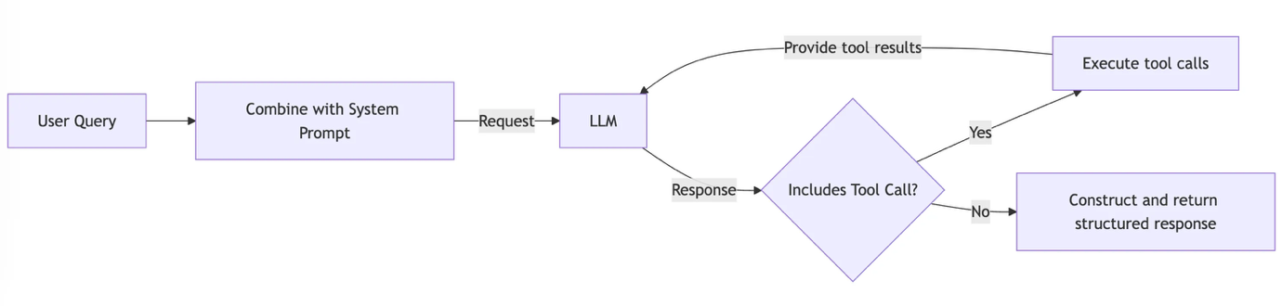

Adding a tool is relatively simple and can be any arbitrary functionality; but it can be as simple as making an api call to an external system fetching information that the LLM can use to enrich it’s response to the user. More complex actions can be chained together making it possible for the LLM to chain multiple tools in sequence to execute more complex tasks or queries.

How could a RAG agent be used with the WFO software - examples?
Typically, when used, the WFO software is an integral part of provisioning at an NREN and manages critical functions of the network. Below are some examples of what a RAG agent could do when embedded into the WFO software and integrated in the OSS/BSS landscape. These are not deliverables of this incubator proposal but examples of tool implementations that could be created for a RAG agent.
a. Real-Time Query Resolution:
- Use Case: Retrieving details about subscriptions, network status, aggregation queries, closest match search.
- How it works: The RAG agent processes the user’s prompt, retrieves relevant information from the WFO and or other integrated OSS/BSS systems and delivers the response. If the tooling is capable it may also reach out to the network and query live information from the device and/or retrieve information from a historical datasource.
b. Automating Workflows:
- Use Case: Automatic ticket creation, service activations and/or provisioning of subscriptions
- How it works: The agent interprets the prompt and uses its tooling to resolve the users intent. If running workflows is available this is possible, but it can also use its knowledge of the WFO information and OSS/BSS information to create tickets.
c. Operational Insights and Reporting:
- Use Case: Generating network performance reports, the monitoring of KPI’s and/or predicting service disruptions.
- How it works: The RAG agent retrieves structured data from OSS/BSS, processes it, and generates user-friendly summaries or visualizations. It may also help troubleshooting when it is integrated with a logging system and/or telemetry system.
- Output: The output of this proposal will be as follows:
  - A python program capable of acting as a RAG agent using information stored in the orchestrator. This program will implement the Pydantic-AI framework (https://ai.pydantic.dev/) and be capable of interacting with an OpenAI API compatible LLM (self-hosted or cloud based)
  - A vector database and LLM search integration of the orchestrator-core backend database. This shall be exposed through an API endpoint. Thes endpoint enabled users to search the orchestrator-core (https://github.com/workfloworchestrator/orchestrator-core) database and interact/export data as they see fit. The LLM integration will enrich the information and provide context to return information based on how the data is queried and stored in the database. Below are prompts that this integration must be able to answer correctly which are to be implemented using a tool chain developed using the pydantic-ai library.
    - How many subscriptions of type <X> does the orchestrator have?
    - What subscriptions of type <X> contains this information < string>?
    - Provide an export of all processes between day 1 and day 2
  - An integration in the orchestrator ui library (https://github.com/workfloworchestrator/orchestrator-ui-library), so that uses can interact with the LLM through the api provided in section b.
  - The opensource Code on github.
  - A Geant infoshare demonstrating the feature and how to extend the RAG with your own tool chain.
  - Documentation about how to setup and bootstrap the RAG agent and how to extend the agent with your own tool chain.
- Users: Any WFO orchestrator user
- Value: The greatest value to the user will be that they will not have to implement as many custom integrations/interfaces to make it possible to navigate the data that is part of an NREN’s automation and orchestration stack. Users can use natural language to describe the information they require, they are in control of how the information is visualized and exported. Furthermore, it enables the creativity of the user to ask the LLM questions, that are otherwise tedious and time consuming to implement for software developers.
- Team: Peter Boers – Architect, SURF and a Software engineer – Rene Dohmen, SURF.
- From 1st of Julu 2025 to 31st of December 2025.
- Resources: Funding for 1FTE to be hired by SURF to create the integration.
- Intellectual Property Rights: No
- Gathering and processing of personal data: No
- Existing project: An addition to work in WP6 led by Simone Spinelli
- Organizations supporting:
- Simone Spinelli, Geant, I will implement the results and contribute with feedback. I would work on this if it would not be executed in the incubator
- Matteo Colantonio, GARR, I will implement the results and contribute with feedback. I would work on this if it would not be executed in the incubator.

