Framework Agreement for the supply and support of Optical Transmission Equipment for time/frequency

Invitation to Tender
Date:
Submission Deadline:
Grant Agreement No.:
Authors: Guy Roberts | GÉANT Procurement & GÉANT Operations
© GÉANT Association on behalf of the GN4-3N project.
The research leading to these results has received funding from the European Union’s Horizon 2024 research and innovation programme under Grant Agreement No. 856728 (GN4-3N).

1 Guidance notes for applicants 2
2 Evaluation of the ITT 4
3 Bidir-amplifiers for time and Frequency 6
3.1 Lot 1: Bidirectional amplifiers for time 8
3.1.1 Lot 1: Mandatory requirements 8
3.1.2 Lot 1: Scoring hardware 9
3.1.3 Lot 1: Scoring software 12
3.2 Lot 2: Bidirectional amplifiers for frequency 13
3.2.1 Lot 2: Mandatory hardware requirements 13
3.2.2 Lot 2: Scoring hardware 14
3.2.3 Lot 2: Scoring software 17
3.3 Lot 3: In-band management Ethernet switch 18
3.3.1 Lot 3: Mandatory requirements 18
3.3.2 Lot 3: Scoring hardware 19
3.3.3 Lot 3: Scoring software 20
4 Installation and support 21
4.1 Lot 4: Installation 21
4.1.1 Lot 4: Mandatory requirements 21
4.1.2 Lot 4: Scoring installation 22
4.2 Lot 5: Support 24
4.2.1 Lot 5: Mandatory requirements 24
4.2.2 Lot 5: Scoring support 25
5 Pricing the Lots 27
5.1 Mandatory requirements when pricing your lots 27
5.2 VAT Treatment of lots 28
Annex A: Glossary 30
Annex B: Optical spectrum allocation and filter design 32
Annex C: FRD Implementation Scope, Testing Criteria and Planning Approach 34

Guidance notes for applicants
- This Invitation To Tender (ITT) forms part of this procurement procedure in accordance with the EC Procurement Directives implemented in the Netherlands by the Dutch Public Procurement Act (Aanbestedingswet 2012, revised 1 July 2016). As with previous documents under this tender, before completing this volume, Bidders should familiarise themselves with the procurement process as described in Volume 0, “Information for Bidders”.
- Please return a completed version of this and all documents and correspondence through the GÉANT e-procurement portal.
- For the purposes of this procurement exercise, GÉANT means the Customer, as defined in the Definitions in Volume 0, or anyone acting on behalf of the Customer who is seeking to invite suitable Bidders to participate in this procurement process.
- “You”/ “Your” or “Bidder” means the body completing these questions i.e. the legal entity seeking to be invited to the next stage of the procurement process and responsible for the information provided. The ‘Bidder’ is intended to cover any economic operator as defined by the Dutch Public Procurement Act (Aanbestedingswet 2012, revised 1 July 2016) and could be: a registered company; charitable organisation; Voluntary Community and Social Enterprise (VCSE); Special Purpose Vehicle; or other form of entity.
- Bidders must ensure that all questions are completed accurately, concisely and, in the format, requested in accordance with the Requirements set out within this document. Failure to do so may result in a Bidder’s submission being disqualified. If the question does not apply to you as the Bidder, please state clearly ‘N/A’ and explain why.
- Where a “Yes” or “No” answer is required, Bidders shall mark the relevant checkbox so as not to create ambiguity for evaluators. Any uncertainty should be raised by the Bidders through clarifications via the eProcurement portal before submitting their response.
- Information must be entered into the appropriate answer boxes except where additional documentation is required or specifically requested.
- Should you need to provide additional Appendices in response to the questions, these should be numbered clearly and listed as part of your declaration. A template for providing additional information is provided at Annex A.
- Where a question requires “evidence”, this means exactly that. Bidders must provide supporting evidence (systems output, reports, other collateral) that backs up the statement or claim being made.
- Answers must relate to the feature GA date no later than 1 June 2025. Any features discussed that are available after this date should have their GA date stated and GÉANT will consider these items as non-compliant.

Evaluation of the ITT
- GÉANT will carry out an evaluation review of the ITT in accordance with the evaluation model published herein. Bidders will have their responses scored on the basis of the most economically advantageous tender.
- Scores will be calculated applying the scoring criteria in Table 2.1. The Procurement Team will establish an evaluation panel (which will comprise subject matter experts from GÉANT), that will use its collective professional judgement to evaluate responses in accordance with the evaluation criteria, weighted and sub-weighted.
Evaluation Criteria | Level 1 weighting | Sub criteria | Level 2 sub weighting | Sub- category | Question # | Question details | Level 3 sub weighting per question
Tba | tba | tba
Table 2.1: Evaluation Model
- GÉANT reserves the right to seek further evidence to support technical compliance statements including requesting equipment to be provided for lab testing purposes.
- The Procurement Team will award scores for those questions related to Quality Evaluation Criteria and non-price commercial questions reflecting reasoned professional judgement as to the merits of each answer.
Awards to be made.
- This ITT is to determine which of the participating Bidders will be selected to supply and install the T/F network. The highest scoring bidder overall shall be awarded the Call Off Contracts to supply the GÉANT Core Time Frequency Network (C-TFN).
Commercial Evaluation
- Pricing Proposals relate to the GÉANT specific FRD requirements and will be scored in accordance with the information provided below.
- Bidders’ responses to the FRD will be assessed on the cost of the Full Reference Design (FRD) and will be scored based on lowest Total Cost of Ownership, i.e. lowest TCO = highest price score. a
- Bidders are required to respond to the Full Reference Design (FRD) provided in this document by completing a complete Bill of Materials (BoM).
- The Bidder with the lowest overall price will be awarded the maximum available score for a specific component or element of the BoM. The remaining tenderers shall be awarded a percentage of the maximum available score relative to the best price. For example: Bidder A submits the lowest overall pricing of €250. Bidder A is awarded the maximum available score – 100%. Bidder B submits pricing of €500. As the price is twice as expensive as Bidder A’s price, Bidder B is awarded 50% of the maximum available score.
Quality - Technical and Services Evaluation
- Questions in these categories will be given a mark out of 6 (0 being the lowest and 6 being the highest) in accordance with Table 2.2 below. Each scored question will be weighted in accordance with table 2.1 to arrive at a percentage for each question.
- Scores will be awarded in accordance with the allocations shown Table 2.2 below. Where specific equipment functions and features are sought, these will be set out in the relevant question and the answers will be scored based on how the solution delivers these functions and features. Bidders should note that their responses should not necessarily be limited to the equipment functions and features listed in the question.
- Where any questions are assessed as obtaining a 0 score, GÉANT shall reject that Bid in full or in part (note that this could relate to the Framework requirements, the GÉANT FRD requirements, or both).

Score | Criteria | Judgement
6 | Response provides a clear and comprehensive solution to GÉANT’s requirements and brings significant added value and benefit to the project, which is supported by evidence (where relevant) and which presents no concerns in relation to deliverability and/or performance and/or transfer of risk to GÉANT. | Exceeds the stated requirements
5 | Response provides a clear and comprehensive solution to GÉANT’s requirements, which is supported by evidence (where relevant) and which presents no concerns in relation to deliverability and/or performance and/or transfer of risk to GÉANT. | Fully meets the stated requirements
3 | Response provides a clear and comprehensive solution to GÉANT’s requirements but there are minor deficiencies in the evidence provided (where relevant) and minor concerns in relation to deliverability and/or performance and/or transfer of risk to GÉANT. | Minor Reservations
1 | Response provides a solution to GÉANT’s requirements but there are major deficiencies in the evidence provided (where relevant) and major concerns in relation to deliverability and/or performance and/or transfer of risk to GÉANT. | Significant Reservations
0 | The response does not meet requirements. | Not Answered / Unacceptable
Table 2.2: Scoring Mechanism
Mandatory Requirements in respect of the GÉANT Specific network (FRD) requirements
- Table 5.1 lists the mandatory requirements that should be applied when building your proposal for GÉANT. These are all mandatory questions and are pass/fail only. Any failure to meet these requirements will disqualify the Bidder. Table 5.2 lists desirable, but not mandatory, items that are to be separately costed.

Bidir-amplifiers for time and Frequency
- GÉANT and the NRENs are working closely with National Measurement Institutes (NMIs) to develop innovative new time-frequency services which we plan to introduce into our network.
- GÉANT is seeking proposals to build time-frequency links during the GN5-2 funding cycle (January 2025 to June 2027). These links will be built on dedicated dark-fibre pairs between National Metrology Institutes (NMIs). GÉANT will procure these fibres in a separate tender.
- This ITT is for bi-directional optical amplifier equipment, management switches and installation to light this fibre.
- The system should allow bi-directional operation to support bi-directional optical CW signals for ultra-high-precision frequency distribution. These signals will be carried in Ch 44 of the ITU-T C-band.
- In addition GEANT plans to use the system to carry both White Rabbit signals and ELSTAB time signals.
- We have divided the solution into separate lots, Bidders are invited to respond to one or more lots as they prefer.
- Bidders who respond to all lots will be awarded additional points.
- In the GN-2, GÉANT intends to build two fibre routes as shown in Figure 1: Indicative fibre routes, north and south. The northern route connects France, Belgium, Netherlands, Germany and Poland. The southern route connects Poland, Czechia, Germany, Austria and Italy.
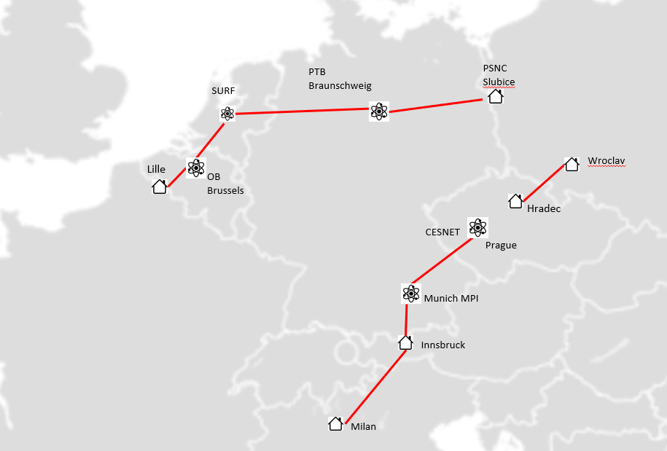
Figure 1: Indicative fibre routes, north and south

- This tender is for equipment for the norther route only. Subject to successful completion of the northern route, GÉANT will build the southern route. We expect the winning bidder to put in place a framework for purchasing equipment which we will use to build the southern route in 2026/7.
- The general requirements described in this section will be scored in accordance with the mechanism described in Table 2.2.
- Each question includes guidance to highlight what GÉANT is seeking and where possible, what a good response should include. Note that Bidders do not have to limit their responses to the guidance and marks are available for responses that exceed the stated requirement, as set out within Table 2.2.
- The Full Reference Design (FRD) describes a nominal fibre topology and a set of bidirectional optical amplifiers and associated management equipment requirements on the Northern route.
- The purpose of the northern route FRD is to understand the cost of the Bidders proposals. This allows us to understand the full cost and evaluate the bids on the principle of MEAT (Most Economically Advantageous Tender). We expect the actual build may vary from the FRD, the FRD gives the Bidders an appropriate impression of scope and reach of the northern route.
- The Bidders must provide a costed solution that meets the FRD and the mandatory requirements in table 5.1. Your response should include:
  - Confirmation that your bid meets all the mandatory items
  - Respond to the scoring questions
  - Completion of the GÉANT FRD spreadsheet with prices

Lot 1: Bidirectional amplifiers for time

Lot 1: Mandatory requirements

- Table 3.1 lists the mandatory requirements for the equipment and software included in the proposal for GÉANT. These are all mandatory questions, and the assessment is pass/fail only. Any failure to meet these requirements will disqualify the Bidder.
 | Category | Number | Parameter | Compliance (YES / NO)
 | H/W  Amplifier | MR1 | The amplifiers provided must be suitable for bi-directional transmission of time and frequency signals over a single fibre I.e. the amplifier must not have any isolators in the path. | Choose an item.
 | H/W  Amplifier | MR2 | The amplifiers must provide gain over at least 8 x 100GHz DWDM channels. (note need to specify the wavelength) | Choose an item.
 | H/W  Amplifier | MR3 | The amplifier internal gain fibre must use a single fibre for gain in each direction, this is to ensure that the transmission delay in both directions of operation is as close as possible. | Choose an item.
 | H/W  Amplifier | MR4 | The amplifiers provided must be optimized for low noise and must have a gain of 21dB. | Choose an item.
 | H/W  Amplifier | MR5 | External optical connectors to the amplifier must be of type Angled Polished Connectors (APC). | Choose an item.
 | H/W  Amplifier | MR6 | The amplifier must support auto restoration of configuration after a power cycle. | Choose an item.
 | H/W  Amplifier | MR7 | The amplifier shelves must have dual -48V DC power feeds. These feeds can be either an integrated dual -48VDC power supply or a separate dual-feed -48VDC external power supply.  The amplifier chassis must have protection against accidental reverse DC polarity connection. | Choose an item.
 | H/W Compatibility | MR8 | The amplifiers provided must be compatible with a filter box conforming to the GÉANT design. This filter will be developed in collaboration with GÉANT, but is not priced in this lot. | Choose an item
 | H/W Compatibility | MR9 | The Bidder must be capable of being installed into the ETSI telco racks provided in the amplifier huts by the optical fibre provider. | Choose an item.
 | Net Man. | MR10 | A Command Line Interface (CLI) must be provided for configuring the bidirectional optical amplifiers. | Choose an item.
 | Net Man. | MR11 | An Application Programming Interface (API) such as CLI, SNMP or REST must be provided for collecting performance monitoring data. | Choose an item.
 | Net Man. | MR12 | The solution must include monitoring of the following amplifier parameters via the CLI and via API:  - input and output optical power independently in both east and west directions  - the laser pump current  - Optical gain | Choose an item.
 | Net Man. | MR13 | The solution must include configuration of the following parameters via the CLI:  - pump current (in case of manual configuration)  - configuration of automatic gain control (if present) | Choose an item.
 | Net Man. | MR14 | The solution must include SNMP alarm reporting, this can be either natively on the amplifiers, or via a centralized Network Management System (NMS). | Choose an item.
 | End of Support | MR15 | The Bidder must confirm that the product range being proposed for the GÉANT will not have its support withdrawn within 10 years from the award of the contract. | Choose an item.
 |  |  | 1 week of training
Table 3.3: Mandatory requirements for equipment and software

Lot 1: Scoring hardware

Q1 – ILA general
GÉANT requires bi-directional optical amplifiers (ILAs) that are capable delivering a low noise performance and are compatible with G.652 and G.655 fibre types.

Please describe (but not be limited to) the following aspects:
- Describe the amplifier solution
- Explain highest gain and launch power available.
- Describe the noise performance
- Describe any built-in filters provided in the amplifier solution
- Explain the pump architecture
- Describe techniques used in your design for reducing risk of gain oscillation/lasing
Please enter your response in the box below or in a separate Appendix using the template provided at Annex A [Max 4 sides of A4].
Click here to enter text.

Q2- Spectral width and flatness of the gain region
GÉANT requires an ILA that operates in the C-band and ITU-T channel 44.
Please describe (but not be limited to) the following aspects:
- Describe specified operating spectrum of the amplifier
- Describe the gain variation over the operating spectrum
- Describe the gain and noise profile of the amplifier outside of the operating spectrum.

Please enter your response in the box below or in a separate Appendix using the template provided at Annex A [Max 4 sides of A4].
Click here to enter text.

Q3 – Link Optical Power Management and power monitoring
GÉANT requires an ILA with gain management and power monitoring functionality.

Please describe (but not be limited to) the following aspects:
- The optical power monitoring features
- Any manual and automated optical gain control features
- User alerts via SNMP or APIs for link optical power changes

Please enter your response in the box below or in a separate Appendix using the template provided at Annex A [Max 4 sides of A4].
Click here to enter text.

Q4 – optical spectrum filters
GÉANT seeks a filter solution which will manage the optical spectrum as described in Annex B. The solution should be flexible to allow new equipment to be added and faulty hardware to be repaired with minimal disruption.

The proposed solution should not include the cost of filters, these will be designed in collaboration with GEANT and will be supplied by GEANT.

Please describe (but not be limited to) the following aspects:

- Your preferred filter solution to match your bi-directional amplifier solution
- How the proposed solution would allow new amplifiers and other equipment such as ELSTAB and WR to be added as needed.
- How replacement of the bi-directional amplifier during fault conditions will affect the other equipment.

Please enter your response in the box below or in a separate Appendix using the template provided at Annex A [Max 4 sides of A4].
Click here to enter text.

Q5 – Connectors
GÉANT seeks a solution which reduces the risk of optical reflections.

Please describe (but not be limited to) the following aspects:

- A description of the connector types (FC/SC/LC) available on the equipment. (Note: as per mandatory requirements these must additionally be of type APC)

Please enter your response in the box below or in a separate Appendix using the template provided at Annex A [Max 4 sides of A4].
Click here to enter text.

Q6 – Power and form factor
GÉANT seeks a solution which fits into telecommunications racks as are typically found in amplifier huts.

GÉANT prefers a compact form factor that fits into typical telco amplifier hut environment.
Please describe (but not be limited to) the following aspects:
The number of RU of rack space needed to fit the amplifier
- Form-factor: mounting in 19” or 21” racks, rack depth, and front or rear access options
- Typical and maximum power consumption
- Power supply redundancy, are PSU units swapable?
- Describe the number and size of power feeds and AC and DC power feed options.
- Temperature operating range for the ILA.

Please enter your response in the box below or in a separate Appendix using the template provided at Annex A [Max 4 sides of A4].
Click here to enter text.

Q12 – Product lifecycle and End-of-Life support
GÉANT requires that all equipment purchased has a clearly defined “end of life” date (captured in the Pricing Catalogue) where it has 5 years or less before being discontinued.
Describe how support will be provided for any equipment purchased, that may be, by the end of the term, coming out of formal support.
Please describe (but not be limited to) the following aspects:
- provide a clear statement on how the bidder will provide support for end-of-life equipment
- a description of how the bidder will mitigate or reduce any need to replace end-of-life equipment
- provide real examples of where your organization has done this previously that are relevant
Please enter your response in the box below or in a separate Appendix using the template provided at Annex A [Max 4 sides of A4].
Click here to enter text.

Lot 1: Scoring software
Q7 - Node Management
GÉANT requires a solution that includes a Node Manager.
Please describe (but not be limited to) the following aspects:
- Craft terminal support, CLI interface. Describe local management interfaces on the ILA
- Configuration – Describe any node configuration back up and configuration download/upload.
- Node software management, especially, the ability to download new versions of software to the ILAs and nodes.
- Network management: Please describe any software that allows multiple amplifiers to be managed from a single user interface.
- The ability to restore the original node configuration after hardware upgrade or replacement in the case of a failure
- Configuration recover after power cycle – we expect that the configuration will be maintained after a power cycle.
Please enter your response in the box below or in a separate Appendix using the template provided at Annex A [Max 4 sides of A4].
Click here to enter text.

Q9 - Management security
GÉANT seeks an amplifier equipment solution with remote management functionality with inherent security features. Please describe the management capabilities with respect to security:
Please describe (but not be limited to) the following aspects:
- SSH access to management interfaces
- RADIUS support RADIUS for account login
- GUIs (web interfaces, etc.) support TLS

Please enter your response in the box below or in a separate Appendix using the template provided at Annex A [Max 4 sides of A4].
Click here to enter text.

Add question on mtbf

Lot 2: Bidirectional amplifiers for optical frequency

Lot 2: Mandatory hardware requirements

- Table 3.1 lists the mandatory requirements for the equipment and software included in the proposal for GÉANT. These are all mandatory questions, and the assessment is pass/fail only. Any failure to meet these requirements will disqualify the Bidder.
 | Category | Number | Parameter | Compliance (YES / NO)
 | H/W Amplifier | MR1 | The amplifier must have Automatic Gain Control (AGC) that works when only carrier wave (unmodulated light) is being amplified. Also, the AGC must work for all powers of the carrier wave light being amplified. I.e this includes when power level is below the ASE noise floor, down to around -60dBm.  (note this requirement is specific to the frequency amplifier) | Choose an item.
 | H/W  Amplifier | MR2 | The amplifiers provided must be suitable for bi-directional transmission of time and frequency signals over a single fibre I.e. the amplifier must not have any isolators in the path. | Choose an item.
 | H/W  Amplifier | MR3 | The amplifiers must provide gain over at least 8 x 100GHz DWDM channels centered around ITU-T channel 44. | Choose an item.
 | H/W  Amplifier | MR4 | The amplifier must work (correctly transmit signals and retain full functionality) for both modulated and non-modulated (carrier wave) signals. | Choose an item.
 | H/W  Amplifier | MR5 | The amplifier internal gain fibre must use a single fibre for gain in each direction, this is to ensure that the transmission delay in both directions of operation is as close as possible. | Choose an item.
 | H/W  Amplifier | MR6 | The amplifiers provided must be optimized for low noise and must have a gain of 21dB. | Choose an item.
 | H/W  Amplifier | MR7 | External optical connectors to the amplifier must be of type Angled Polished Connectors (APC). | Choose an item.
 | H/W  Amplifier | MR8 | The proposed solution must support auto restoration of ILA configuration after a power cycle. | Choose an item.
 | H/W  Amplifier | MR9 | The amplifier shelves must have dual -48V DC power feeds. These feeds can be either an integrated dual -48VDC power supply or a separate dual-feed -48VDC external power supply.  The amplifier chassis must have protection against accidental reverse DC polarity connection. | Choose an item.
 | H/W Compatibility | MR10 | The amplifiers provided must be compatible with a filter box conforming to the GÉANT design. This filter will be developed in collaboration with GÉANT , but is not part of the bill of materials (BoM) | Choose an item
 | H/W Compatibility | MR11 | The Bidder must be capable of being installed into the ETSI telco racks provided in the amplifier huts by the optical fibre provider. | Choose an item.
 | Net Man. | MR12 | A Command Line Interface (CLI) must be provided for configuring the bidirectional optical amplifiers. | Choose an item.
 | Net Man. | MR13 | An Application Programming Interface (API) such as CLI, SNMP or REST must be provided for collecting performance monitoring data. | Choose an item.
 | Net Man. | MR14 | The solution must include monitoring of the following amplifier parameters via the CLI and via API:  - input and output optical power independently in both east and west directions  - the laser pump current  - Optical gain | Choose an item.
 | Net Man. | MR15 | The solution must include configuration of the following parameters via the CLI:  - pump current (in case of manual configuration)  - configuration of automatic gain control (if present) | Choose an item.
 | End of Support | MR16 | The Bidder must confirm that the product range being proposed for the GÉANT FRD will not have its support withdrawn within 10 years from the award of the contract. | Choose an item.
Table 3.4: Mandatory requirements for equipment and software

Lot 2: Scoring hardware

Q1 – ILA general
GÉANT requires bi-directional optical amplifiers (ILAs) that are capable delivering a low noise performance and are compatible with G.652 and G.655 fibre types.

Please describe (but not be limited to) the following aspects:
- Describe the amplifier solution
- Explain highest gain and launch power available.
- Describe the noise performance
- Describe any built-in filters provided in the amplifier solution
- Explain the pump architecture
- Describe techniques used in your design for reducing risk of gain oscillation/lasing
Please enter your response in the box below or in a separate Appendix using the template provided at Annex A [Max 4 sides of A4].
Click here to enter text.

Q2- Spectral width and flatness of the gain region
GÉANT requires an ILA that operates in the C-band and ITU-T channel 44.
Please describe (but not be limited to) the following aspects:
- Describe specified operating spectrum of the amplifier
- Describe the gain variation over the operating spectrum
- Describe the gain and noise profile of the amplifier outside of the operating spectrum.

Please enter your response in the box below or in a separate Appendix using the template provided at Annex A [Max 4 sides of A4].
Click here to enter text.

Q3 – Link Optical Power Management and power monitoring
GÉANT requires an ILA with gain management and power monitoring functionality.

Please describe (but not be limited to) the following aspects:
- The optical power monitoring features
- Any manual and automated optical gain control features
- User alerts via SNMP or APIs for link optical power changes

Please enter your response in the box below or in a separate Appendix using the template provided at Annex A [Max 4 sides of A4].
Click here to enter text.

Q4 – optical spectrum filters
GÉANT seeks a filter solution which will manage the optical spectrum as described in Annex B. The solution should be flexible to allow new equipment to be added and faulty hardware to be repaired with minimal disruption.

The proposed solution should not include the cost of filters, these will be designed in collaboration with GEANT and will be supplied by GEANT.

Please describe (but not be limited to) the following aspects:

- Your preferred filter solution to match your bi-directional amplifier solution
- How the proposed solution would allow new amplifiers and other equipment such as ELSTAB and WR to be added as needed.
- How replacement of the bi-directional amplifier during fault conditions will affect the other equipment.

Please enter your response in the box below or in a separate Appendix using the template provided at Annex A [Max 4 sides of A4].
Click here to enter text.

Q5 – Connectors
GÉANT seeks a solution which reduces the risk of optical reflections.

Please describe (but not be limited to) the following aspects:

- A description of the connector types (FC/SC/LC) available on the equipment. (Note: as per mandatory requirements these must additionally be of type APC)

Please enter your response in the box below or in a separate Appendix using the template provided at Annex A [Max 4 sides of A4].
Click here to enter text.

Q6 – Power and form factor
GÉANT seeks a solution which fits into telecommunications racks as are typically found in amplifier huts.

GÉANT prefers a compact form factor that fits into typical telco amplifier hut environment.
Please describe (but not be limited to) the following aspects:
The number of RU of rack space needed to fit the amplifier
- Form-factor: mounting in 19” or 21” racks, rack depth, and front or rear access options
- Typical and maximum power consumption
- Power supply redundancy, are PSU units swapable?
- Describe the number and size of power feeds and AC and DC power feed options.
- Temperature operating range for the ILA.

Please enter your response in the box below or in a separate Appendix using the template provided at Annex A [Max 4 sides of A4].
Click here to enter text.

Q12 – Product lifecycle and End-of-Life support
GÉANT requires that all equipment purchased has a clearly defined “end of life” date (captured in the Pricing Catalogue) where it has 5 years or less before being discontinued.
Describe how support will be provided for any equipment purchased, that may be, by the end of the term, coming out of formal support.
Please describe (but not be limited to) the following aspects:
- provide a clear statement on how the bidder will provide support for end-of-life equipment
- a description of how the bidder will mitigate or reduce any need to replace end-of-life equipment
- provide real examples of where your organization has done this previously that are relevant
Please enter your response in the box below or in a separate Appendix using the template provided at Annex A [Max 4 sides of A4].
Click here to enter text.

Lot 2: Scoring software
Q7 - Node Management
GÉANT requires a solution that includes a Node Manager.
Please describe (but not be limited to) the following aspects:
- Craft terminal support, CLI interface. Describe local management interfaces on the ILA
- Configuration – Describe any node configuration back up and configuration download/upload.
- Node software management, especially, the ability to download new versions of software to the ILAs and nodes.
- Network management: Please describe any software that allows multiple amplifiers to be managed from a single user interface.
- The ability to restore the original node configuration after hardware upgrade or replacement in the case of a failure
- Configuration recover after power cycle – we expect that the configuration will be maintained after a power cycle.
Please enter your response in the box below or in a separate Appendix using the template provided at Annex A [Max 4 sides of A4].
Click here to enter text.

Q9 - Management security
GÉANT seeks an amplifier equipment solution with remote management functionality with inherent security features. Please describe the management capabilities with respect to security:
Please describe (but not be limited to) the following aspects:
- SSH access to management interfaces
- RADIUS support RADIUS for account login
- GUIs (web interfaces, etc.) support TLS

Please enter your response in the box below or in a separate Appendix using the template provided at Annex A [Max 4 sides of A4].
Click here to enter text.

Lot 3: In-band management Ethernet switch

Lot 3: Mandatory requirements

- Table 3.1 lists the mandatory requirements for the equipment and software included in the proposal for GÉANT. These are all mandatory questions, and the assessment is pass/fail only. Any failure to meet these requirements will disqualify the Bidder.
 | Category | Number | Parameter | Compliance (YES / NO)
 | H/W Ethernet | MR8 | The proposed solution must support auto restoration of ILA configuration after a power cycle. | Choose an item.
 | H/W Ethernet | MR9 | The amplifier shelves must have dual -48V DC power feeds. These feeds can be either an integrated dual -48VDC power supply or a separate dual-feed -48VDC external power supply.  The amplifier chassis must have protection against accidental reverse DC polarity connection. | Choose an item.
 | H/W Ethernet | MR10 | The amplifiers provided must be compatible with a filter box conforming to the GÉANT design. This filter will be developed in collaboration with GÉANT , but is not part of the bill of materials (BoM) | Choose an item
 | H/W Ethernet | MR11 | The Bidder must be capable of being installed into the ETSI telco racks provided in the amplifier huts by the optical fibre provider. | Choose an item.
 | H/W Ethernet | MR12 | The offer must include a management Ethernet switch that is in a separate chassis from the optical amplifier. This must have at least eight (8) Ethernet ports of 1/10GE for local device management. | Choose an item
 | H/W Ethernet | MR13 | The Ethernet switch must have aan optical interface to connect to the OSC channels on the line fibre capable of operating on up to 90km of G.652 or G.655 fibre. | Choose an item
 | H/W  Ethernet | MR14 | The Ethernet switch must have either an integrated dual -48VDC power supply or a separate dual-feed -48VDC to 240VAC inverter for powering the Ethernet switch. | Choose an item21
 | H/W  Ethernet | MR16 | The in-band monitoring channels must not reside within the C-band. Only S-band or L-band OSC channels are allowed. Insertion of the OCS channel must be via the filter provided by GEANT. For details see the annex showing the GÉANT wavelength plan. | Choose an item.
 | H/W  Ethernet | MR17 | A Command Line Interface (CLI) must be provided for configuring the Ethernet Switch. | Choose an item.
 | End of Support | MR32 | The Bidder must confirm that the product range being proposed for the GÉANT FRD will not have its support withdrawn within 10 years from the award of the contract. | Choose an item.
Table 3.5: Mandatory requirements for equipment and software

Lot 3: Scoring hardware

Q8 - Management via OSC channel.
GÉANT requires a solution that includes remote management via an OSC.
Please describe (but not be limited to) the following aspects:
- Please describe your solution for Optical Supervisory Channel (OSC) or similar for remote management of the amplifier.
- Please reference your answer to the GÉANT wavelength plan in shown in Annex A

Please enter your response in the box below or in a separate Appendix using the template provided at Annex A [Max 4 sides of A4].
Click here to enter text.

Q6 – Ethernet Switch
GÉANT seeks an Ethernet switch which will be used to manage equipment in each amplifier site.

GÉANT prefers an Ethernet switch in a compact form factor that fits into typical telco amplifier hut environment.
Please describe (but not be limited to) the following aspects:
- The

Please enter your response in the box below or in a separate Appendix using the template provided at Annex A [Max 4 sides of A4].
Click here to enter text.

Q6 – Power and form factor
GÉANT seeks a solution which fits into telecommunications racks as are typically found in amplifier huts.

GÉANT prefers an Ethernet switch in a compact form factor that fits into typical telco amplifier hut environment.
Please describe (but not be limited to) the following aspects:
- The number of RU of rack space needed to fit the amplifier
- Form-factor: mounting in 19” or 21” racks, rack depth, and front or rear access options
- Typical and maximum power consumption
- Power supply redundancy, are PSU units swapable?
- Describe the number and size of power feeds and AC and DC power feed options.
- Temperature operating range for the ILA.

Please enter your response in the box below or in a separate Appendix using the template provided at Annex A [Max 4 sides of A4].
Click here to enter text.

Q12 – Product lifecycle and End-of-Life support
GÉANT requires that all equipment purchased has a clearly defined “end of life” date (captured in the Pricing Catalogue) where it has 5 years or less before being discontinued.
Describe how support will be provided for any equipment purchased, that may be, by the end of the term, coming out of formal support.
Please describe (but not be limited to) the following aspects:
- provide a clear statement on how the bidder will provide support for end-of-life equipment
- a description of how the bidder will mitigate or reduce any need to replace end-of-life equipment
- provide real examples of where your organization has done this previously that are relevant
Please enter your response in the box below or in a separate Appendix using the template provided at Annex A [Max 4 sides of A4].
Click here to enter text.

Lot 3: Scoring software

Q7 – Ethernet Switch Management
GÉANT requires an Ethernet switch at each amplifier site
Please describe (but not be limited to) the following aspects:
- Craft terminal support, CLI interface. Describe local management interfaces on the ILA
- The ability to restore the original Switch configuration after hardware upgrade or replacement in the case of a failure
- Configuration recover after power cycle – we expect that the configuration will be maintained after a power cycle.
Please enter your response in the box below or in a separate Appendix using the template provided at Annex A [Max 4 sides of A4].
Click here to enter text.

Q9 - Management security
GÉANT seeks an amplifier equipment solution with remote management functionality with inherent security features. Please describe the management capabilities with respect to security:
Please describe (but not be limited to) the following aspects:
- SSH access to management interfaces
- RADIUS support RADIUS for account login
- GUIs (web interfaces, etc.) support TLS

Please enter your response in the box below or in a separate Appendix using the template provided at Annex A [Max 4 sides of A4].
Click here to enter text.

Installation and support

Lot 4: Installation

Lot 4: Mandatory requirements
- Table 3.1 lists the mandatory requirements for the equipment and software included in the proposal for GÉANT. These are all mandatory questions, and the assessment is pass/fail only. Any failure to meet these requirements will disqualify the Bidder.

 | Category | Number | Parameter | Compliance (YES / NO)
 | Install | MR22 | The bi-directional amplifier must be installed at all sites by the Bidder | Choose an item.
 | Install | MR23 | An Ethernet switch must be installed at all sites by the Bidder. | Choose an item.
 | Install | MR24 | An optical filter as described in Annex B (provided by GEANT) must be installed at all sites by the Bidder. | Choose an item.
 | Install | MR25 | All power cabling must be installed at each site to power the Ethernet switch and amplifier from the top rack distribution of  -48VDC | Choose an item.
 | Install | MR26 | The bidder must agree to follow the installation principles set out in annex C. | Choose an item.

Table 4.6: Mandatory requirements for equipment support

Lot 4: Scoring installation
Q13 – Delivery & Installation of new Equipment
The Bidder is requested to provide information in respect of how they would supply and install the equipment at the locations specified in the FRD, as well as how existing, decommissioned equipment will be handled. This should be referenced to the guidelines outlined in Annex B.

Please describe (but need not be limited to) the following aspects:
- equipment delivery
- Installation process
- Fibre connection and cleaning procedures
- Power connection
- System configuration
- Power balancing
- Commissioning process
- Handover documentation

Please enter your response in the box below or in a separate Appendix using the template provided at Annex A [Max 4 sides of A4].
Click here to enter text.

Q11 – Installation
GÉANT requires support for the installed equipment.
Bidders should describe their installation team and the countries that they can operate in.

- The table below lists all the countries included in the GÉANT specific FRD highlighted in orange. Bidders should complete this and include in their response, to indicate where First Line Maintenance and Spares Parts holding can be offered. If support is not currently available in a country, please describe how you plan to provide support in that country.

Country (note yellow shaded are Mandatory from Stage 1) | In Country support capability
Country (note yellow shaded are Mandatory from Stage 1) | In Country support?
Austria
Belgium
Czech Republic
United Kingdom
Estonia
Finland
France
Germany
Italy
Latvia
Lithuania
Poland
Portugal
Slovakia
Slovenia
Spain
Switzerland
The Netherlands

  - Note that support is required in the countries highlighted orange in the embedded excel as these are included in the links to be built in 2025-2027.

Please enter your response in the box below or in a separate Appendix using the template provided at Annex A [Max 4 sides of A4].
Click here to enter text.

Lot 5: Support

Lot 5: Mandatory requirements
- Table 3.1 lists the mandatory requirements for the equipment and software included in the proposal for GÉANT. These are all mandatory questions, and the assessment is pass/fail only. Any failure to meet these requirements will disqualify the Bidder.
- GÉANT expects the spares support to be ‘Next Day’. Next Day is defined as spares delivered within the next business day, subject to receipt of request by 15:00 local time of service desk the previous day.
- GÉANT is seeking service guarantees in respect of equipment supply and spares support. Bidders are required to confirm their commitment to the stated Key Performance Metrics in the table below.

 | Category | Number | Parameter | Compliance (YES / NO)
 | Support | MR27 | The bidder must hold spares to be able to replace any bi-directional amplifier and the Ethernet switches deemed to be faulty. | Choose an item
 | Support | MR28 | The bidder must be responsible for shipping the switch and amplifier to site and replace faulty hardware within the time specified in the service level agreement. | Choose an item
 | Support | MR29 | the Bidder must be wholly responsible for RMA workflow logistics, including ensuring the FLM engineer arrives to site with the correct replacement part and must remove the faulty part from site. | Choose an item
 | Support | MR30 | The bidder must provide a single point of contact (typically and email address) where GEANT can raise tickets requesting hardware repair. | Choose an item
 | Support | MR31 | All communication between the Bidder’s support personnel and the GÉANT/ Operations Centre must be in the English language to the Common European Framework standard level B2 as a minimum. | Choose an item.
 | End of Support | MR32 | The Bidder must confirm that the product range being proposed for the GÉANT FRD will not have its support withdrawn within 10 years from the award of the contract. | Choose an item.
 |  |  | Hold two spares

Table 4.7: Mandatory requirements for equipment support

Incident / Issue / Problem Classification | Definition/Description
Critical/P1 | - Incidents that cause loss of service or continuous instability of mission-critical functionality and have no workaround.  - Inability to use a feature or functionality that is currently relied upon for mission-critical functionality, for example, extended loss of management.  - Intermittent issues that affect mission-critical functionality.
Major/P2 | Incidents that are service affecting, but not causing loss of service or loss of mission-critical functionality. Loss of redundancy of critical components.
Minor/P3 | Incidents that are not impairing /interrupting the service or any mission-critical functionality.  - Time-sensitive questions or information requests.  - Information and RFO requests.  - Standard questions on configuration or functionality of equipment.  - Non-urgent RMA requests.  - Cosmetic defects.
Table 4.8: Incident classifications

Lot 5: Scoring support
Q10 - Technical Assistance Centre (TAC)
GÉANT requires access to expert technical support from the Bidder in respect of the solutions being offered. Describe how GÉANT will be supported by Bidders Technical Assistance Centre (TAC).
Please describe (but not be limited to) the following aspects:
- a single point of contact for incident reporting
- provide the physical location of the support and state its operational hours for equipment provided to GÉANT.
- Please explain how you plan to support the Ethernet switch equipment
- an explanation of how specific incident reporting is actioned (e.g. portal, email, etc)

Please enter your response in the box below or in a separate Appendix using the template provided at Annex A [Max 4 sides of A4].
Click here to enter text.

Q11 – Hardware Support, Spares holding and First Line Maintenance
GÉANT requires support for the installed equipment.
Bidders should describe their proposed Hardware Support model.
Please describe (but not be limited to) the following aspects:

- Describe how your spares holding and logistics process will enable you to meet the Next Day response times.
- The table below lists all the countries included in the GÉANT specific FRD highlighted in orange. Bidders should complete this and include in their response, to indicate where First Line Maintenance and Spares Parts holding can be offered. If support is not currently available in a country, please describe how you plan to provide support in that country.

Country (note yellow shaded are Mandatory from Stage 1) | In Country support capability |  | Spares holding
Country (note yellow shaded are Mandatory from Stage 1) | In Country FLM Reach Yes/No | Next business day support? | In Country Spares Parts Holding Yes/No
Austria
Belgium
Czech Republic
United Kingdom
Estonia
Finland
France
Germany
Italy
Latvia
Lithuania
Poland
Portugal
Slovakia
Slovenia
Spain
Switzerland
The Netherlands

  - Please note that some PoPs do not allow replacement units to be shipped to site. In this specific case they must be brought to site by the First Line Maintenance technician and Bidders should explain how they can support this.
  - Note that support is required in the countries highlighted orange in the embedded excel as these are included in the links to be built in 2025-2027.

Please enter your response in the box below or in a separate Appendix using the template provided at Annex A [Max 4 sides of A4].
Click here to enter text.

Pricing the Lots
- The Full Reference Design (FRD) describes the fibre topology and expected amplifier locations.
- The FRD is to be used by the Bidders to build the proposed solution. The following embedded excel file provides the details of the FRD. Please be aware that the solution that is ultimately built by GÉANT may vary from the FRD as firm fibre information becomes available and refinements need to be made to the topology.
- Add to units for spares

- The purpose of the FRD is to understand the cost of the Bidders proposals. We expect the actual build may vary from the FRD, with the FRD giving an impression of scope and reach.
- GÉANT will provide the successful Bidder with as-built fibre test measurements once these have been handed over to GÉANT.
- We will not be procuring all the dark fibre for the whole C-TFN network in one go. We plan to procure dark fibre in two stages, the north fibre in 2025 and the southern link fibre from 2026 onwards subject to the success of the northern link.
- The Bidders must provide a costed solution that meets the FRD and the mandatory requirements in table 6.5. Your response should include:
  - A statement of compliance for the mandatory requirements listed in table below.
  - A document detailing the full design
  - Provide a GÉANT Pricing List for all equipment included in the FRD.
- To evaluate the proposals GÉANT will score solutions based on the quality of the technical capabilities of your solution and the cost of your solution.

Mandatory requirements when pricing your lots
- Table 6.5 lists the mandatory requirements that should be applied when pricing your lots. These are all mandatory questions, and the assessment is pass/fail only. Any failure to meet these requirements will disqualify the Bidder.

Lot | Parameter | Compliance (YES / NO)
All  lots | The Bidders must complete the relevant tab in the ‘FRD pricing matrix’ excel spreadsheet for your lot | Choose an item.
Lots 1&2 | The Bidder must include the price of all software licence fees for any functions used in their solution | Choose an item.
Lots  1&2 | The Bidder’s solution must include a priced design for the OSC channels and Ethernet network that will allow the amplifiers to be managed without the need for separate out-of-band management channels. | Choose an item.
Lot 3 | The Bidder’s solution must include a price for constructing the GÉANT time/frequency link as described in the FRD. This must include network surveys, delivery, logistics, project management, waste disposal, installation, testing and commissioning to the locations as listed in the Full Reference Design (FRD). The pricing must be fully documented. | Choose an item.
Lot3 | The proposed solution must include the price of preparing documents as needed: site-survey check list, pre-install check list, site acceptance and handover documents. | Choose an item.
Lot 3 | The Bidder’s solution must include any site surveys if these are required. | Choose an item.
Lot 4 | The Bidders proposal must include the cost of next business day on-site support for all sites identified in the Full Reference Design (FRD). This support will be triggered in the case of a hardware or software fault in the amplifiers that requires on-site action to rectify. | Choose an item.
Table 5.9: Mandatory GÉANT requirements for the build and support

VAT Treatment of lots
- Bidders are required to provide evidence of their compliance with applicable VAT legislation in the countries where OTE is to be installed and commissioned ahead of GÉANT taking title following UAT.
- GÉANT has VAT registrations in the countries listed in the FRD.
- Bidders will be required to respond on delivery and installation in both EU countries as well as specific reference to those countries listed in the FRD that fall outside of the EU. Note that GÉANT typically expects the reverse charge mechanism or local VAT to be used, or that the Prime Contractor has a VAT registration in the specific country.
- There are very specific VAT rules relating to supply and install, which vary significantly from one EU country to the next.

Q14 – VAT Compliance - Delivery of new Equipment
GÉANT requires Bidders to evidence their compliance with relevant VAT and Customs legislation in all the countries listed in the FRD.

Please describe (but need not be limited to) the following aspects:
- details in respect of the plan for equipment delivery for each site in relation to VAT
- confirmatory evidence that equipment to be delivered in one country and driven across a border will be carried out in accordance with the correct VAT treatment for the country in which GÉANT will take ownership of the equipment

Please enter your response in the box below or in a separate Appendix using the template provided at Annex A [Max 4 sides of A4].
Response

Annex A: Glossary

Term | Definition
2016 Regulations | Dutch Public Procurement Act (‘Aanbestedingswet 2012’), revised July 1, 2016
Bidder | A candidate (including consortia or joint venture arrangements) who submits a response to this Invitation To Tender (ITT)
Bi-directional amplifier | The optical amplifier to be used for amplifying bi-directional time and frequency signals.
Commencement Date | The later date of the two dates which are made on the signing of this Agreement is signed by both parties
Committed Delivery Date (CDD) | the agreed date on which each Service is contracted to be put into operation
Contract Notice | Contract Notice published in the Official Journal of the European Union
C-TFN | Core-Time Frequency Network. This is the network being built by GÉANT and the NRENs to distribute time and frequency signals around Europe.
DF | Dark fibre
ESPD | European Single Procurement Document. A self-declaration of a business’s financial status, abilities and suitability for a public procurement procedure. It is used as a preliminary evidence of fulfilment of the conditions required in public procurement procedures across the EU.
Final Bid | The bid(s) prepared and submitted by each Bidder in response to the ITT
FRD | The full reference design (FRD) includes a topology and list of amplifier sites that should be used by the Bidder to create a design and related bill of materials. .
IRU | Indefeasible right of use
ITT | Invitation to Tender – this document and any subsequent clarifications, including references all the various Volumes comprising the tender documentation
Mandatory requirements | Mandatory technical and support requirements that must be met for the Bidder to qualify
MSA | Master Service Agreement – part of the contract documents
MTBF | Mean Time Between Failures.
MTCR | Mandatory Technical and Commercial Requirements. This document sets out the mandatory requirements that the Bidder must be able to meet before proceeding to the next stage of the GÉANT procurement.
NMI | National Metrology Institute (NMI) is the institute responsible for setting national UTC
Node | A node refers to a network element. A network element is made up of one or more shelves or chassis that are logically represented in the NMS as a single node.
NREN | National Research and Education Network that provides national connectivity to universities, colleges, schools and research centres.
OC | the GÉANT Operations Centre.
Operational Service Date (OSD) | the date on which each Service is accepted in accordance with Volume 3, Annex 3
Optical Distribution Frame (ODF) | a fibre optic management unit used to organize fibre optic cable connections.
Point of Presence (PoP) | a PoP is a building which houses terminal equipment to which the Service are connected
Portal | the GÉANT eProcurement Portal available at www.supply2.GÉANT .org
Procurement Team | a cross-departmental team from GÉANT established for this procurement
Proposed Contract | the terms and conditions being proposed as the basis for a final contract set out in Volume 3
SQ | Supplier Questionnaire
Solution | the proposed equipment and associated support, software and licensing that together makes up a solution to meet the requirements defined in the tender documentation.
Standstill | A short (at least 10 calendar day) pause between the point when the contract award decision is notified to bidders, and the final contract conclusion, during which time Bidders can challenge the decision.
Total Contract Value | Total Contract Value (TCV) is a metric that represents the value of one-time and recurring charges
Vendor | A vendor of optical transmission equipment

Annex B: Optical spectrum allocation and filter design
The diagram and table below show the preliminary spectrum allocation plan for the C-TFN.
- The C-Band is divided into four 8-channel bands with 1-channel guard bands, which can be implemented with four cascaded 8skip1 filters:
  - C23-C30
  - C32-C39
  - C41-C48 (primary application band)
  - C50-C57
- Part of the L-band wavelength range 1565-1580nm is reserved for future use.

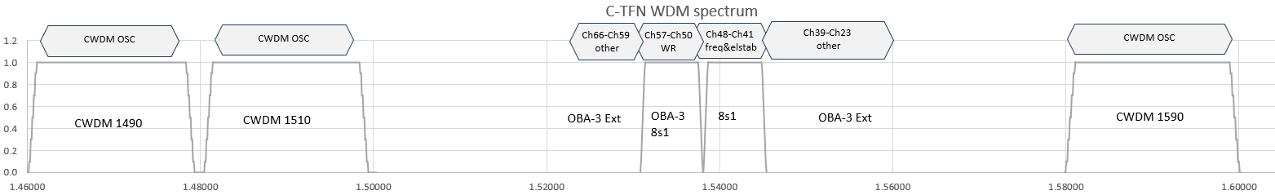
Figure 2: T/F wavelength plan

- A total of 8 channels (41-48) are available for frequency (and ELSTAB if needed), allowing a one channel gap for the 8s1 transition
- A total of 8 channels (50-57) are available for White Rabbit, allowing a one channel gap for the 8s1 transition.
- Channels 23-39 are for other uses (Ext port)
- Channels 59-66 are for other uses (Ext port)
- OSC channels have two options:
  - Option 1: CWDM channel 1590nm
  - Option 2: CWDM channels 1490nm and 1510nm (preferred)
The following diagrams show two different connectivity options for the spectrum filters.
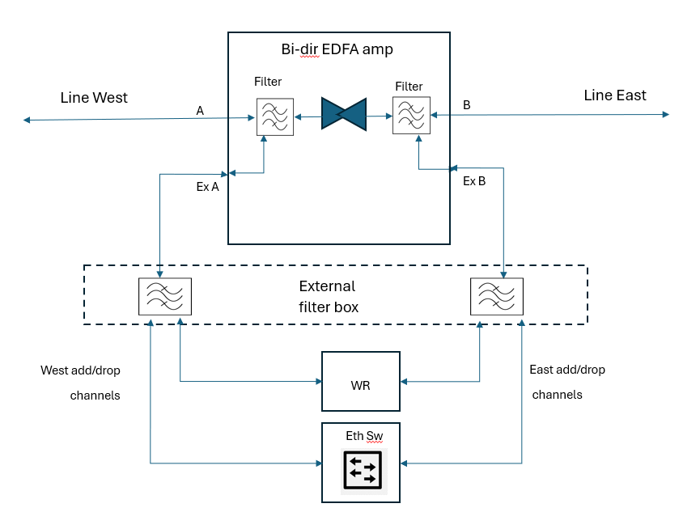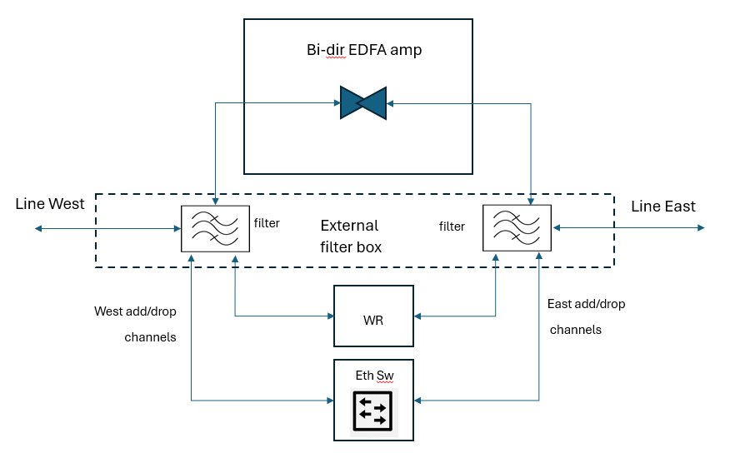

Figure 3: filter connectivity options

Annex C: FRD Implementation Scope, Testing Criteria and Planning Approach
- The scope of the implementation is described below, for all sites where amplifier equipment will be deployed:
  - Link Design & Bill of Material
  - Pre-installation Site survey
  - Delivery of Equipment to its site
  - Installation of amplifier equipment, filters and local management switches.
  - Configuration and balancing of amplifiers
  - Configuration and testing of management system (if present)
  - Acceptance of equipment and management system
  - Removal of all waste/packaging materials from site
  - Supply of agreed acceptance/handover documentation
- To help achieve the objectives listed above, GÉANT has defined the following work-streams to facilitate the network refresh:
- Pre-Deployment Planning – based upon the bidders proposed design, the bidder should prepare site survey templates for equipment site configuration & design templates, a project plan, implementation plans.
- Design Engineering & Planning - prepare documents describing the final as-built state of the completed T/F links.
- Site Survey – where needed, conduct a pre-installation site survey to document the fibre cabling, HVAC, power and space conditions, along with any potential concerns regarding impact to human health and safety, while adhering to GÉANT change management guidelines.
- Implementation – Full management of bidder (or Partner) resources required for the implementation activities (e.g., surveys, equipment/cabling installation, end to end route testing/acceptance, service/trunk migration support (with GÉANT)), coordinating installation times based on site availability and complete installation of new network.
- Testing – Provide required test and acceptance documentation as agreed with GÉANT. Note that Implementation is not complete at any site until GÉANT has Accepted the Implementation at such site in writing. Testing activities to include:
    - Functionality validation
    - Site testing
    - Test Results Handover

