Filter design for GEANT fibre links in the C-TFN

Context
GEANT is building optical fibre links for the C-TFN that will interconnect European NMIs. These optical links require bi-directional EDFA amplifiers roughly every 70km. Considering that the fibre is expected to be in place for up to 10 years and mid-life upgrading of equipment will be difficult, it is important to ensure that the filter design is future-proofed; we need filters to support all current and future services envisaged for the C-TFN.
The proposed DWDM filters will allow amplifiers, ELSTAB equipment and White Rabbit equipment can be added at amplifier site as needed.

Spectrum
Dense Wavelength Division Multiplexing (DWDM) is divided up over several optical bands, the bands S, C and L are summarised below.
Band | Name | Wavelength Range (nm)
S-band | Short Wavelength Band | 1460–1530 nm
C-band | Conventional Band | 1530–1565 nm
L-band | Long Wavelength Band | 1565–1625 nm

The C-band is the most widely used in long-haul DWDM because it has the lowest attenuation and is compatible with EDFA (Erbium-Doped Fiber Amplifiers). The L-band allows network providers to expand capacity and is also EDFA-compatible. The S-band can be used in cases where additional capacity is needed, but is not EDFA compatible.
The original C-band (1530nm-1565nm) has been expanded twice since its first introduction to provide more channels and increase network capacity by extending it into the S and L bands: Extended C-band (1530nm–1570 nm) and the Super C-band (1525–1575 nm). These bands are depicted in appendix A.

Design considerations
There are two vendors of bi-directional optical amplifier commonly used by the NMI community which will form the basis of this design proposal, these are:
- Keopsys https://www.keopsys.com/portfolio/bi-directional-fiber-amplifier/
- PIK Time Systems: https://piktime.com/offer/oba-3/
Other amplifiers are also available, but are not considered in this analysis.
It is not clear which of these amplifiers will be chosen in GEANT’s public procurement process, for this reason two designs are proposed each using one of the two amplifier types. The design of the amplifiers used in the C-TFN pathfinder are shown in Appendix B. The design of the OBA3 amplifier is shown in Appendix C.

Option 1, OBA3:
Option 1 is designed around the use of the OBA3 bi-directional optical amplifiers from PIK Time Systems. This amplifier has an in-built filter and an express port, for details see Appendix D. For this design I have assumed that the OBA3 would be delivered with the 8s1 filter centred on Ch44. I have also assumed that the performance of the 8s1 filter conforms to this specification:
https://www.iridian.ca/product/dwdm-8s1-1559-39/
In this design the output of the OBA3 amplifier express port is forwarded to an off-the-shelf 100 GHz DWDM filter, this provides the following ports:

The external C-band DWDM filter is housed in an external rack mount chassis:

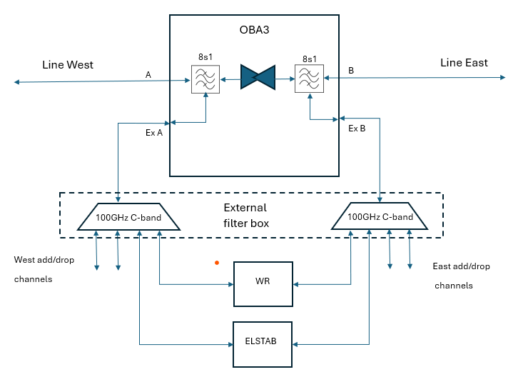

Option 2, Keopsys
Option 2 is designed around the use of the Keopsys bi-directional optical amplifier. This amplifier does not have a in-built filter.
In this design the 8s1 and 100GHz c-band filters are both housed in an external box. The frequency plan remains the same:

The external C-band DWDM filter is connected to the OBA3 as shown in the diagram below:

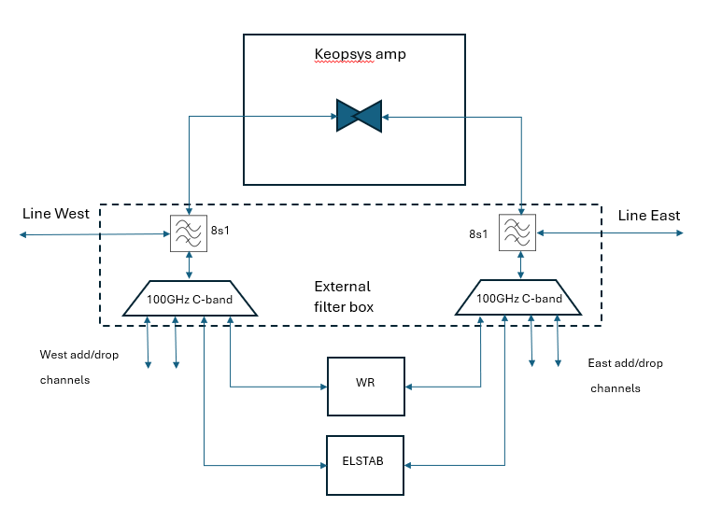

Spectrum allocation for C-TFN filters
The diagram and table below show a possible spectrum allocation plan for the C-TFN.

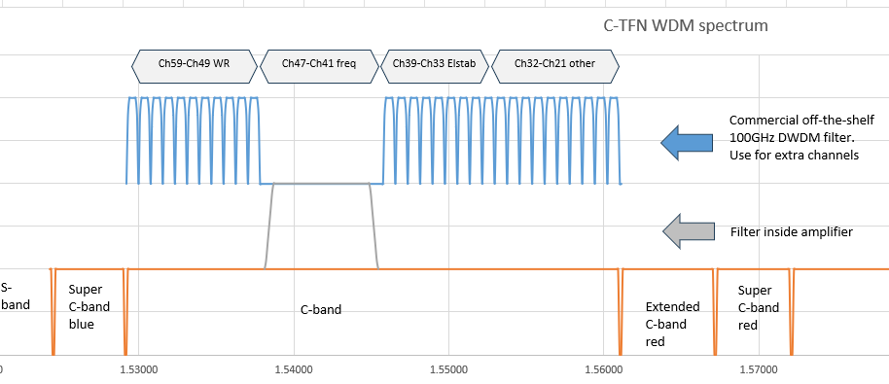

- Channels 49-69 are available for White Rabbit
- Channels 41-47 are available for frequency (and ELSTAB if needed)
- Channels 33-39 are for ELSTAB
- Channels 21-32 for auxiliary functions such as management channels

Appendix A: DWDM spectrum

The diagram below shows the DWDM spectrum.
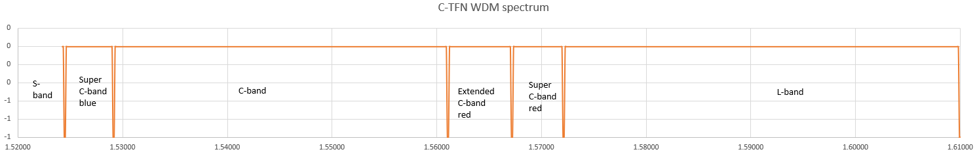

Appendix B: Pathfinder filter:
The diagram below shows the filter spectrum as used in the C-TFN pathfinder link
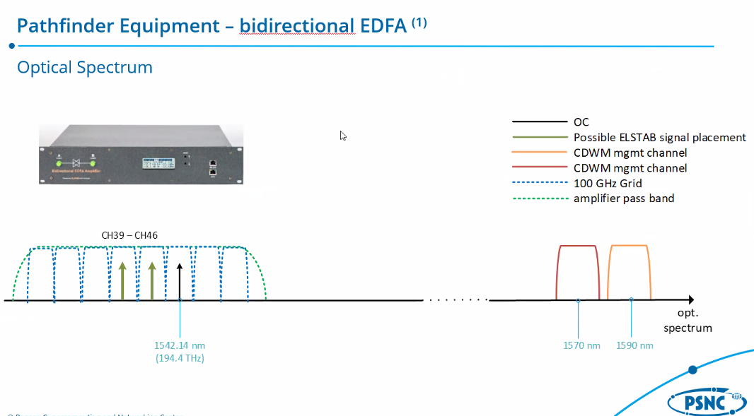

Appendix C: OBA3 from PIK Time Systems
The two diagrams below show the design of the OBA3 amplifier.
