Filter design for GÉANT fibre links in the C-TFN

Overview
This document outlines the proposed design for optical filters in the GÉANT links within the C-TFN network. These filters are designed to partition the optical spectrum, ensuring the fibre can support all planned services while also being adaptable to accommodate future services.

Contents
Overview 1
Context 3
Spectrum 3
Fibre 3
Amplifier Hardware 3
Spectrum allocation for C-TFN filters 4
GÉANT Filter implementation 5
Maximising flexibility 5
Minimising connectors 5
Design 7
Appendix A: ITU-T spectrum 9
Appendix B: Pathfinder filter: 10
Appendix C: OBA3 from PIK Time Systems 11
Appendix D: CESNET filter design 12

Context
GÉANT is building optical fibre links for the C-TFN that will interconnect European NMIs. These optical links require bi-directional EDFA amplifiers approximately every 70km. Considering that the fibre is expected to be in place for up to 10 years and mid-life upgrading of equipment will be difficult, it is important to ensure that the filter design is future-proofed; we need a design for filters that will support all current and future services envisaged for the C-TFN.
The proposed DWDM filters should support bi-directional amplifiers for frequency transmission and ELSTAB equipment. They should also allow White Rabbit equipment to be added at each amplifier site as needed.

Spectrum
Dense Wavelength Division Multiplexing (DWDM) is divided up over several optical bands, the bands S, C and L are summarised below.
Band | Name | Wavelength Range (nm)
S-band | Short Wavelength Band | 1460–1530 nm
C-band | Conventional Band | 1530–1565 nm
L-band | Long Wavelength Band | 1565–1625 nm

The C-band is the most widely used in long-haul DWDM because it has the lowest attenuation and is compatible with EDFA (Erbium-Doped Fiber Amplifiers). The L-band allows network providers to expand capacity and is also EDFA-compatible. The S-band can be used in cases where additional capacity is needed but the S-band is not EDFA compatible.
The original C-band (1530nm-1565nm) has been expanded twice since its first introduction to provide more channels and increase network capacity by extending it into the S and L bands: Extended C-band (1530nm–1570 nm) and the Super C-band (1525–1575 nm). These bands are depicted in appendix A.

Fibre
GÉANT will acquire a pair of fibres for use in the C-TFN. The filters described herein will be installed on both fibres, irrespective of whether amplifiers are initially deployed on one or both.

Amplifier Hardware
There are three vendors of bi-directional optical amplifier commonly used by the NMI community which will form the basis of this design proposal, these are:
- Keopsys https://www.keopsys.com/portfolio/bi-directional-fiber-amplifier/
- OBA-3 from PIK Time Systems: https://piktime.com/offer/oba-3/
- CzechLight bidirectional amplifiers https://czechlight.cesnet.cz/en/network-elements/amplifier/
The Keopsys and OBA-3 amplifiers considered in this analysis. CzechLight amplifier is also worth considering, but not included in this analysis.
It is not known which of these amplifiers will be chosen in GÉANT ’s public procurement process, for this reason two designs are proposed each using one of these two amplifier types.

Spectrum allocation for C-TFN filters
The diagram and table below show the proposed spectrum allocation plan for the C-TFN.
- The C-Band is divided into four 8-channel bands with 1-channel guard bands, which can implemented with four cascaded 8skip1 filters:
  - C23-C30
  - C32-C39
  - C41-C48 (primary application band)
  - C50-C57

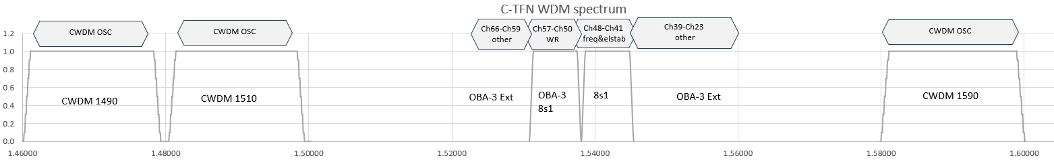

- A total of 8 channels (41-48) are available for frequency (and ELSTAB if needed), allowing a one channel gap for the 8s1 transition
- A total of 8 channels (50-57) are available for White Rabbit, allowing a one channel gap for the 8s1 transition.
- Channels 23-39 are for other uses (Ext port)
- Channels 59-66 are for other uses (Ext port)
- OSC channels have two options
  - Option 1: CWDM channel 1590nm
  - Option 2: CWDM channels 1490nm and 1510nm

- The operating wavelength of all 8skip1 filters should cover 1500 nm to 1600 nm, i.e. the EXP port passes wavelength from 1500 nm to 1600 nm minus the passband of the filter, so that all OSC options are supported.
- Where the OBA-3 is used, the built-in C41-C48 8skip1 filter can be used.
- Auxiliary 8-channel bands allow future expansion or doubling-up
- Alternatively, one of the 8-channel blocks can be demultiplexed into individual channels

GÉANT Filter implementation
There are two contradictory design goals: maximising flexibility and minimising connectors.

Maximising flexibility
For maximum flexibility, only a first 8skip-1 filter for C41-C48 (including internal to OBA-3) followed by CWDM add/drop filters for the OSC would be implemented at the start of the service. Further 8skip1 filters or 8-channel DEMUX could then be cascaded as needed.
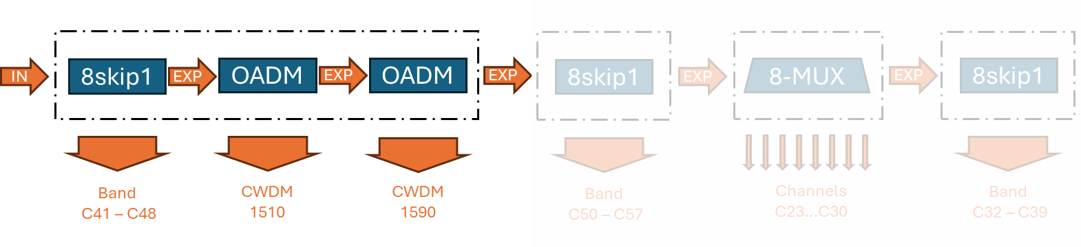
Advantages of this approach:
- Whether whole bands or individual channels are dropped can be decided at a later stage, when the actual needs are clearer
- The order of the 8skip1 filters or 8-DEMUX can be optimised for minimum insertion loss in specific bands
- Deviations from the 4x8skip1 structure are possible
Disadvantages of this approach:
- Bands added later will increasingly suffer from excess insertion loss and reflections from connectors

Minimising connectors
To minimise the connectors of connectors, a complete set of filters would be spliced and deployed to each location. Only two variants are needed, one for OBA-3 and one for other amplifiers that don’t feature an internal 8skip1 filter.
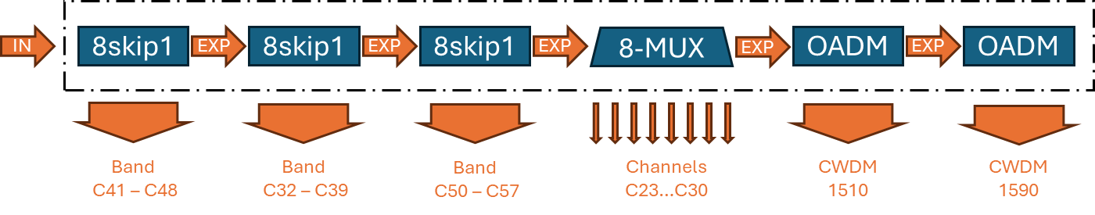
Advantages of this approach:
- Minimal insertion loss and reflections
- OSC OADMs can moved to the end of the filter chain (SFPs tend to be more tolerant to attenuation than bidirectionally amplified applications)
Disadvantages of this approach:
- Filter structure has to be decided in advance
- Additional DEMUX after the 8skip1 filter cost extra insertion loss

Design
The design of the amplifiers used in the C-TFN pathfinder are shown in Appendix B. The details of the OBA-3 amplifier is shown in Appendix C.

Option 1, OBA-3:
Option 1 is designed around the use of the OBA-3 bi-directional optical amplifiers from PIK Time Systems. This amplifier has an in-built filter and an express port, for details see Appendix D. For this design I have assumed that the OBA-3 would be delivered with the 8skip1 filter centred on Ch44. It is assumed that the performance of the 8skip1 filter conforms to this specification:
https://www.iridian.ca/product/dwdm-8s1-1559-39/
In this design the output of the OBA-3 amplifier express port is forwarded to an external filter housed in an external rack mount chassis

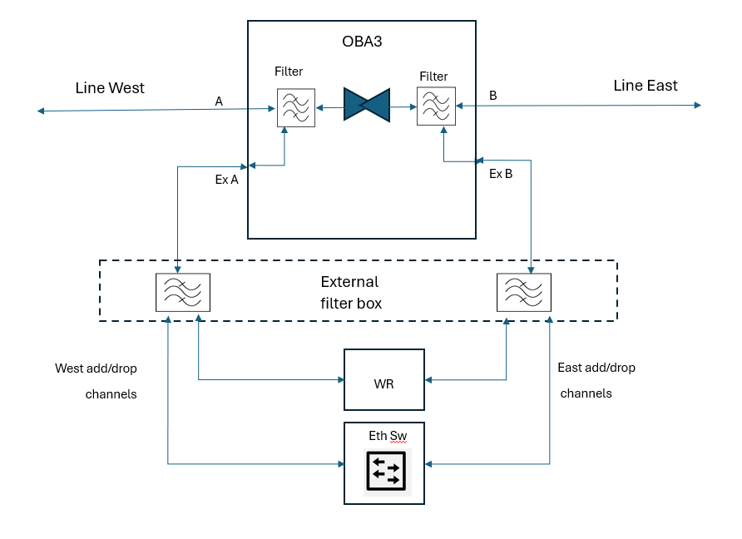

Option 2, Keopsys
Option 2 is designed around the use of the Keopsys bi-directional optical amplifier. This amplifier does not have an in-built filter.
In this design the filters for frequency, WR, Elstab and optical supervisory channels is housed in an external box. The frequency plan remains the same.
The external C-band DWDM filter is connected to the Keopsys as shown in the diagram below:

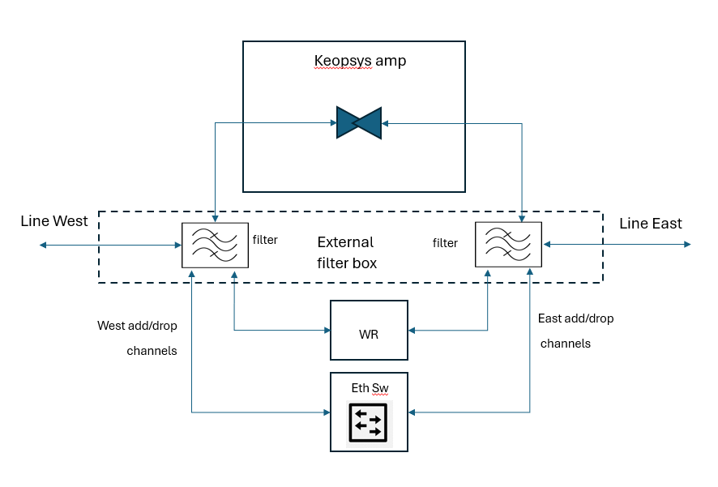

Appendix A: ITU-T spectrum
The following diagram shows the ITU-T CWDM and DWDM bands and channels
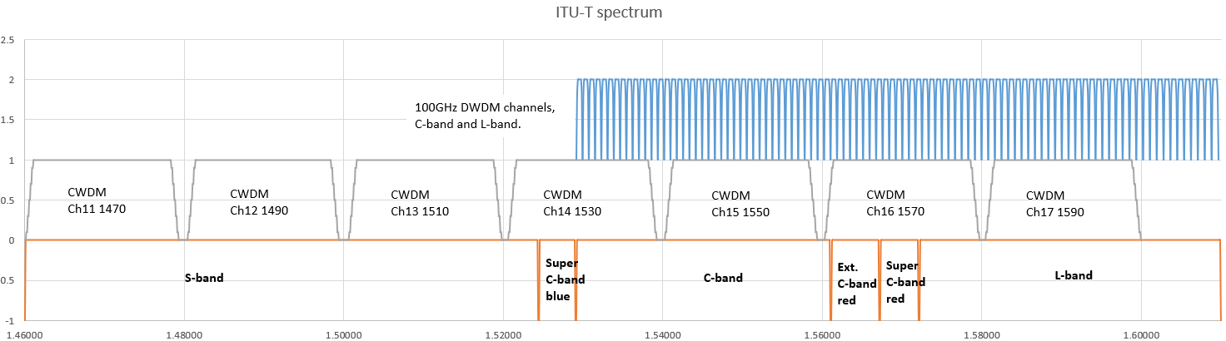

Appendix B: Pathfinder filter:
The diagram below shows the filter spectrum as used in the C-TFN pathfinder link

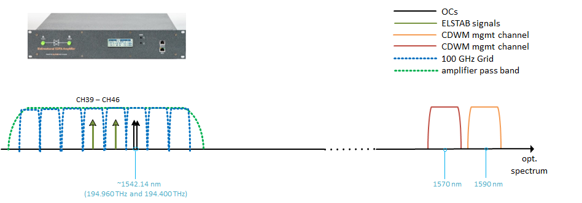

Appendix C: OBA3 from PIK Time Systems
The two diagrams below show the design of the OBA3 amplifier.
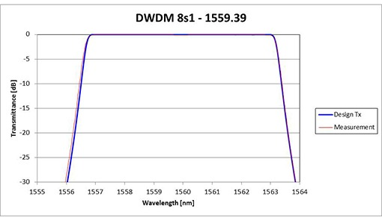
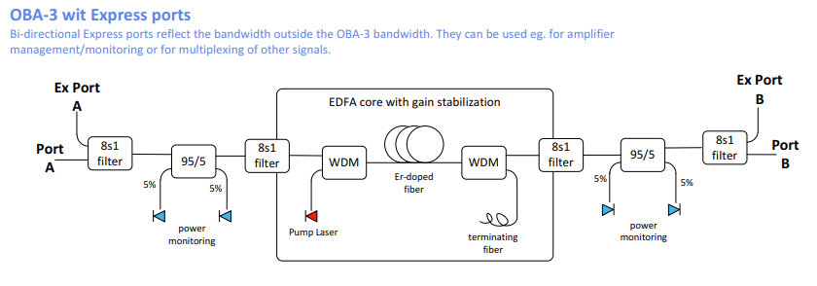

Appendix D: CESNET filter design
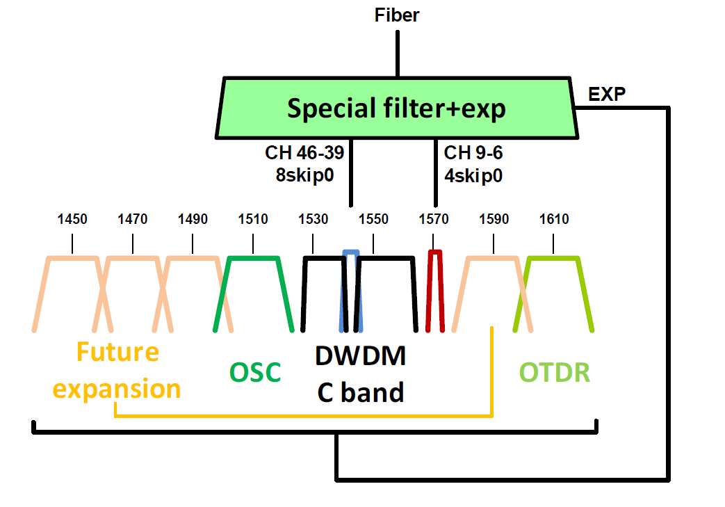
In the CESNET network, pre-filters are installed on most optical fibers on the line side of the DWDM equipment. These pre-filters enable the coexistence of a commercial DWDM system with non-data services such as the transmission of accurate time and coherent frequency and also allows for future expansion. External filters:
- Bi-directional operation for time and frequency: A 8skip0 filter on channels 46 to 39 (1540.56 - 1546.12 nm)
- Future use: A 4skip0 filter is deployed on ITU channels 9 to 6 (1570.42 - 1572.89 nm)
Filters in the Ribbon DWDM system:
- White Rabbit: DWDM ITU channels 30-35 (1553.33 - 1549.32 nm) are reserved on the Ribbon DWDM system for WR.
- OSC channels : The Ribbon DWDM system uses the standard at 1510 nm channel (1510 and 1590 nm in the case of single fiber)
- OTDR channel: The Ribbon DWDM system uses 1610 nm channel.

